Project
  - Deadline: Monday 03/12/2025 @ 23:59
[Total Mark is 14]

Data Mining
DS472

Student Details: CRN: 13724
Name:Asma Abdulqader  Name: Maha Alanazi  Name:Sana Alzahrah  Name:Maram Bawazir |  |  | ID: 220043599  ID: 220043515  ID: 220052569  ID: 220018729

Instructions:
- You must submit two separate copies (one Word file and one PDF file) using the Assignment Template on Blackboard via the allocated folder. These files must not be in compressed format.
- It is your responsibility to check and make sure that you have uploaded both the correct files.
- Zero mark will be given if you try to bypass the SafeAssign (e.g. misspell words, remove spaces between words, hide characters, use different character sets, convert text into image or languages other than English or any kind of manipulation).
- Email submission will not be accepted.
- You are advised to make your work clear and well-presented. This includes filling your information on the cover page.
- You must use this template, failing which will result in zero mark.
- You MUST show all your work, and text must not be converted into an image, unless specified otherwise by the question.
- Late submission will result in ZERO mark.
- The work should be your own, copying from students or other resources will result in ZERO mark.
- Use Times New Roman font for all your answers.

Project Overview and Instructions

Project Overview:
This project provides a comprehensive overview of data mining, covering both fundamental and advanced techniques, while offering real-world insights into customer behavior and business decision-making in e-commerce.
The primary objective of this project is to familiarize students with performing data mining tasks on a dataset. The dataset will include various data, such as age, workclass, education, sex, and occupation, among others. You will go through the different stages of data mining to extract meaningful insights from the data.

Instructions:
- In this project, each group of students will select a dataset and apply the steps mentioned in each question provided below. Each group is required to utilize a distinct data mining algorithm and technique to produce the results.
- Students will work in groups of 2-3 students and compile their work into a single report for submission along with other project materials. The project must be submitted on Blackboard by one designated member of the group (the project leader).

Dataset:
- You must use the following dataset from the UCI Machine Learning Repository. Adult - UCI Machine Learning Repository

Question One
3 Marks
Learning Outcome(s):1
Explain different data mining tasks, problems and the algorithms most appropriate for addressing them.

Data Preparation and Loading
Task:
- Download the dataset and convert it to .arff or use .csv directly.


- Load the dataset into WEKA.
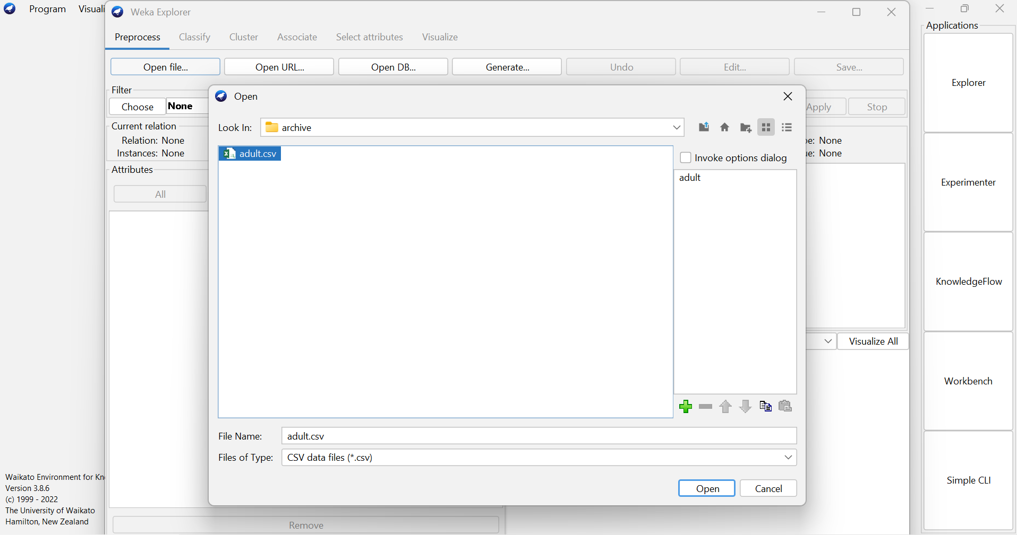
- Describe the attributes and the target variable (income).

1. age
Number of years since the person was born.
Represents the individual's age.
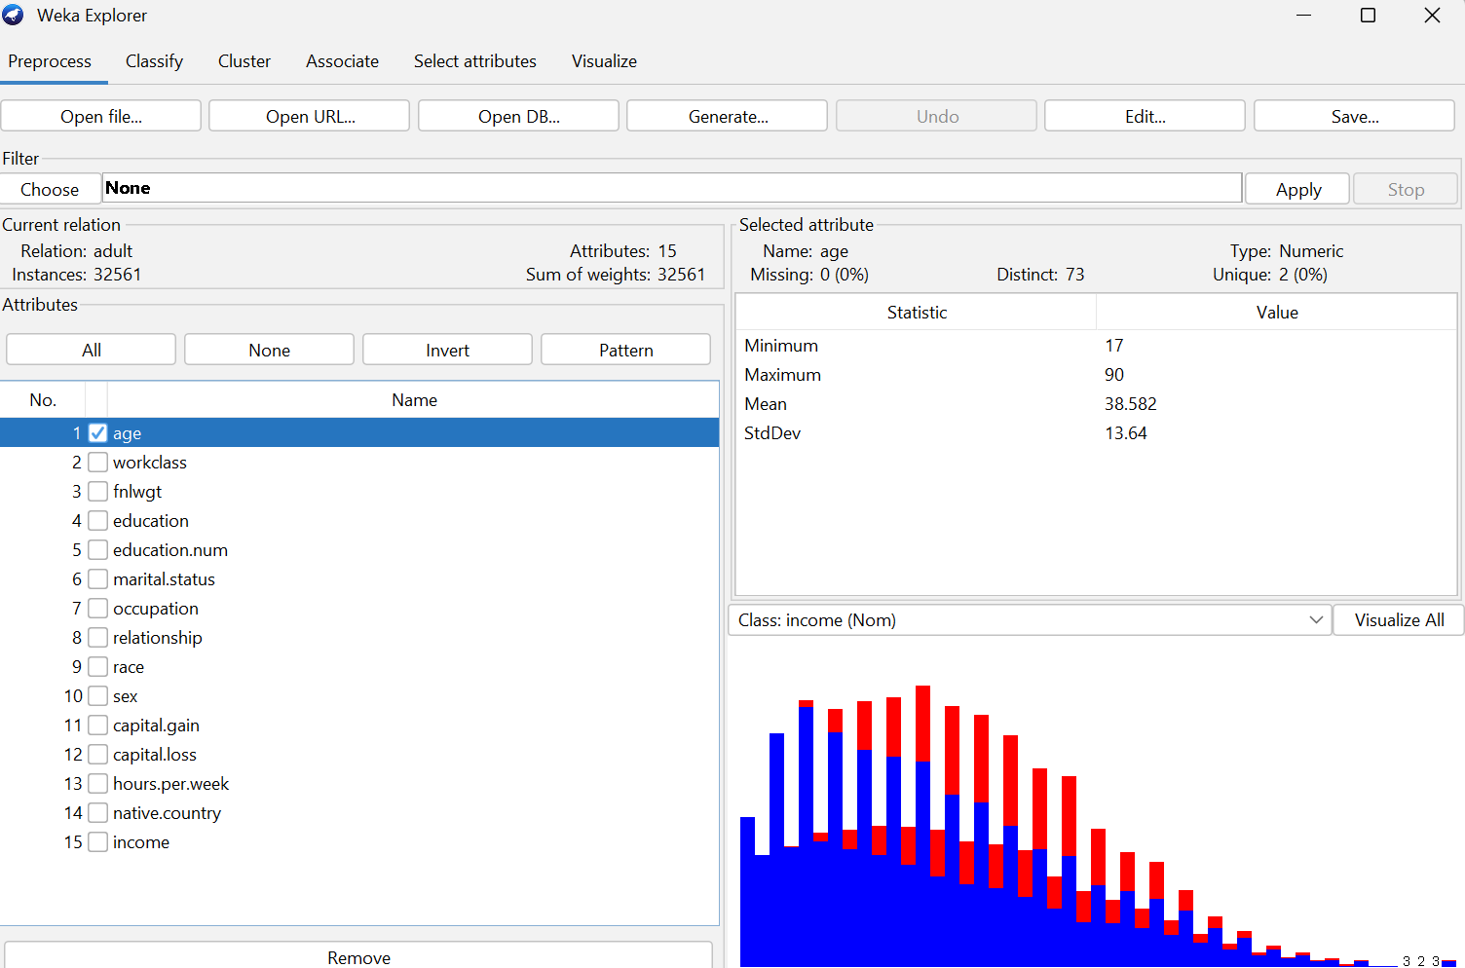

2. workclass
A categorical feature indicating the type of employment.
Examples: Private Self-employed Government etc.
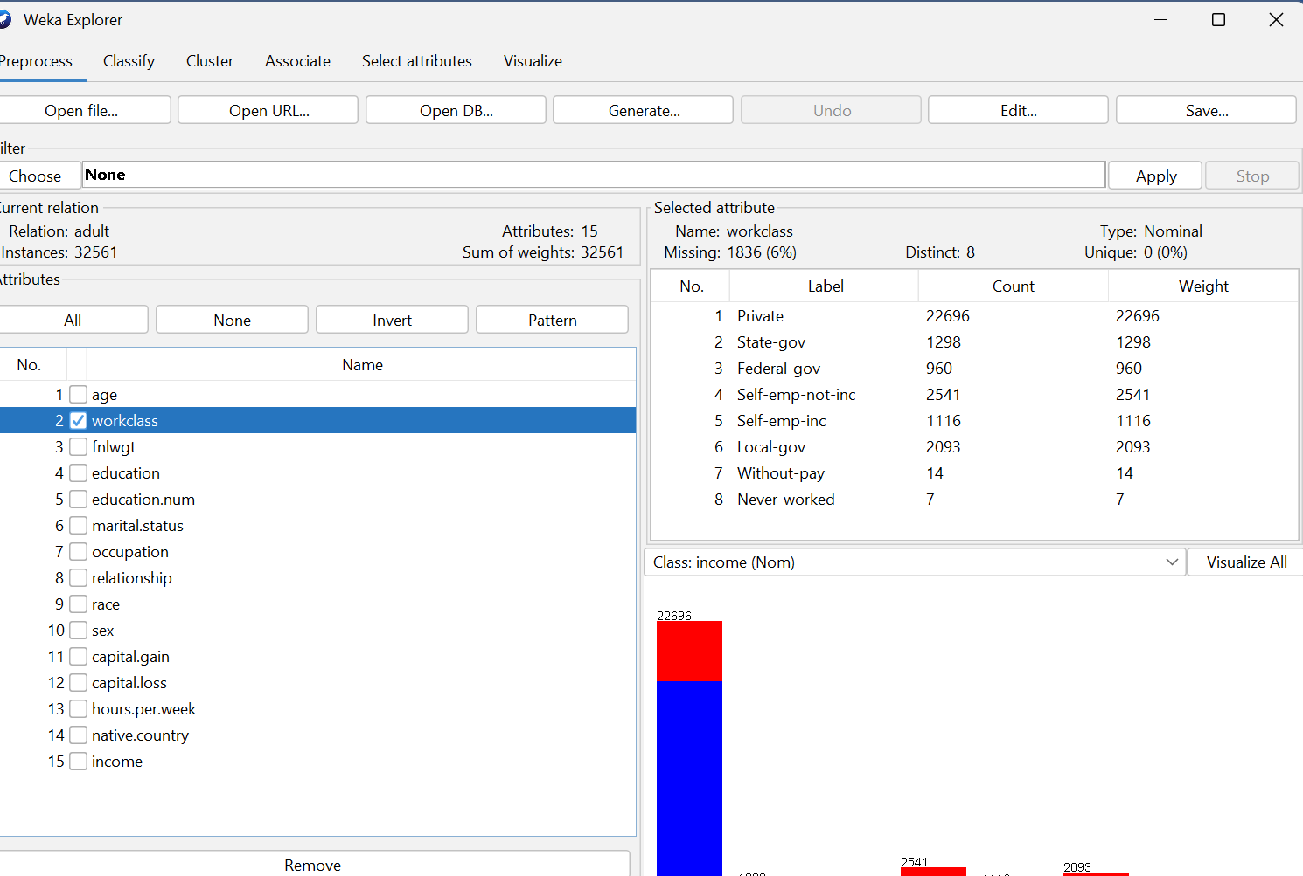

3. fnlwgt
Final weight
A number that shows how many persons the record is supposed to represent in the population.
It doesn't say anything about a person's traits; it's mostly for sampling.
.
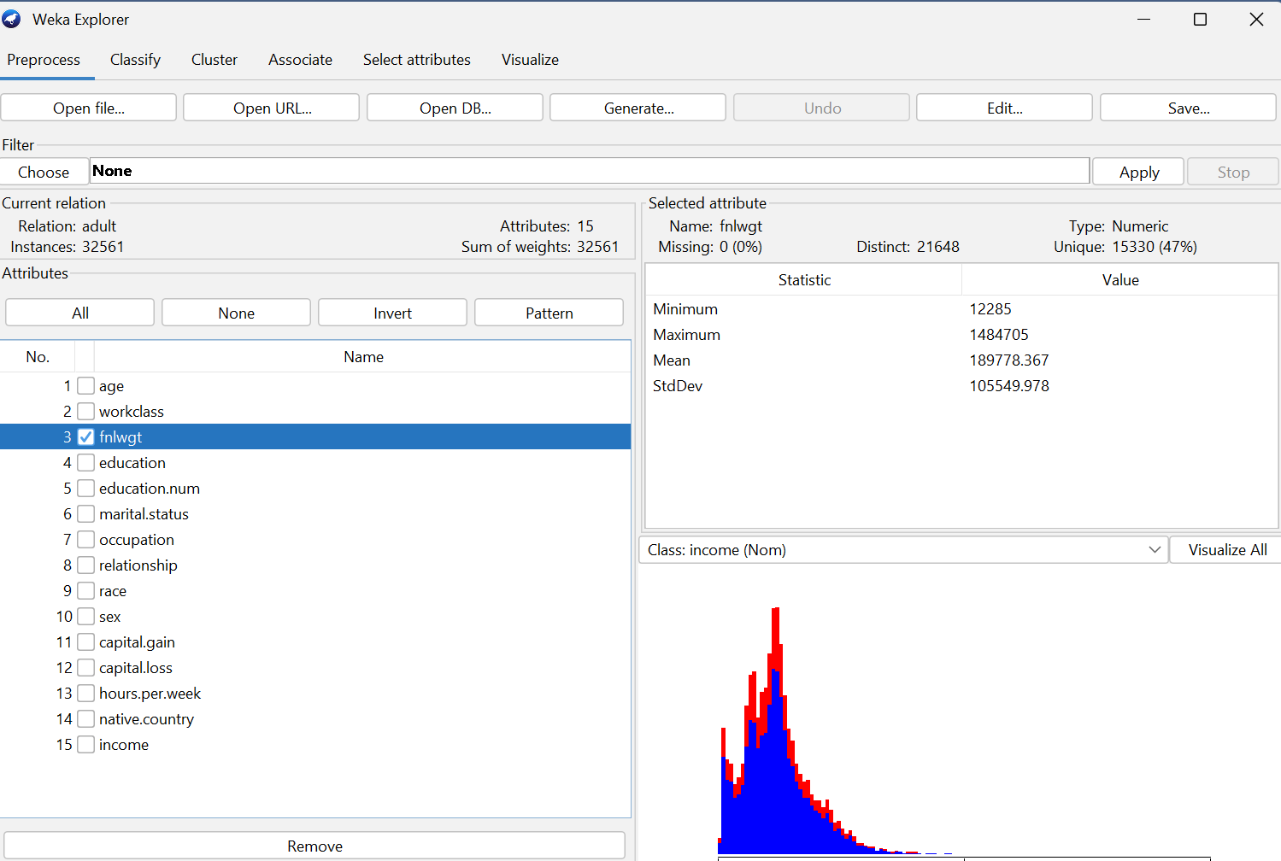

4. education
The highest level of education achieved by the individual.
Examples: Bachelors Masters HS-grad Some-college.
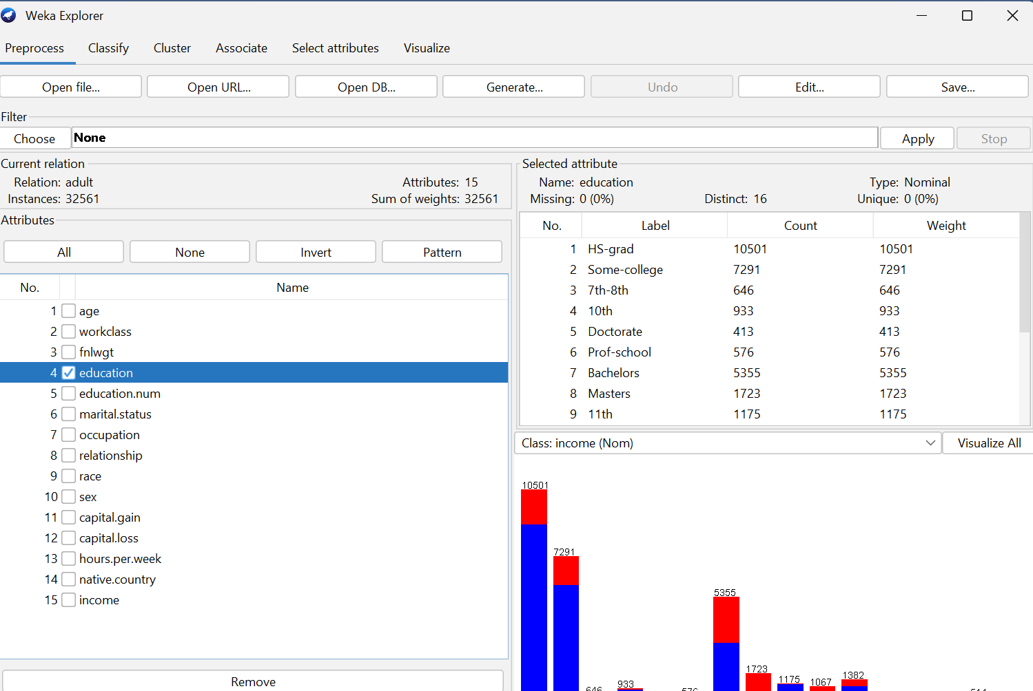

5. education-num
A numeric version of the education level.
Each education category is mapped to a number (e.g., Bachelors = 13).
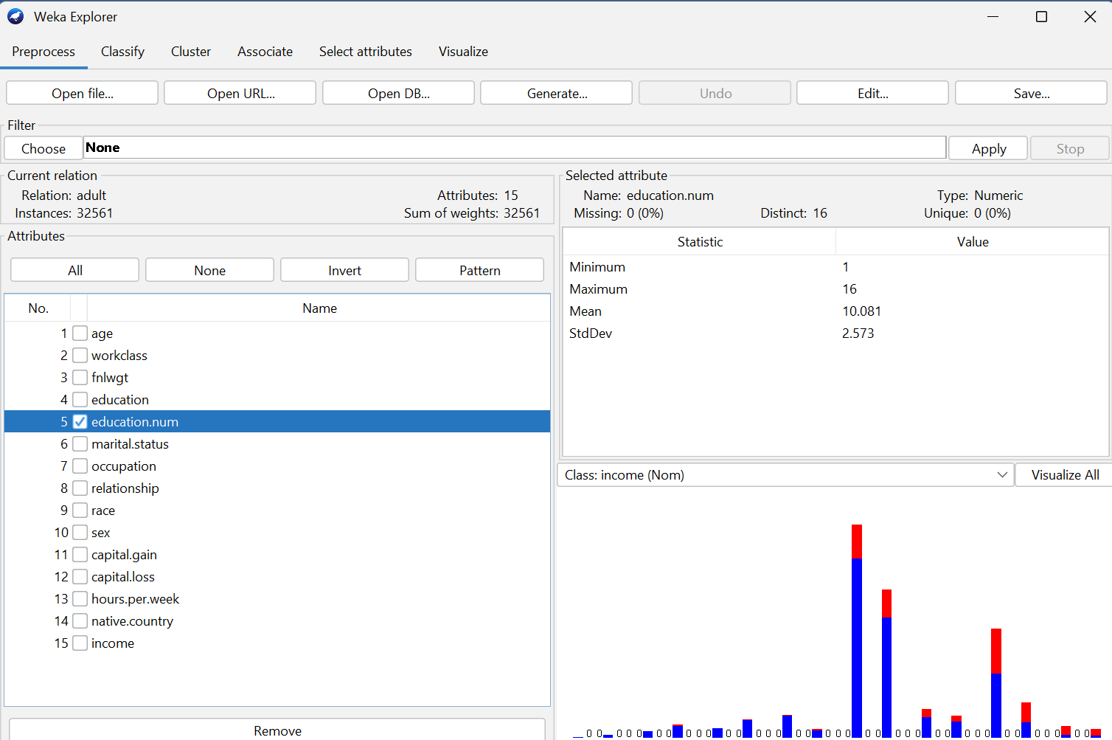

6. marital-status
Describes the person's marital situation.
Examples: Never-married Married-civ-spouse Divorced
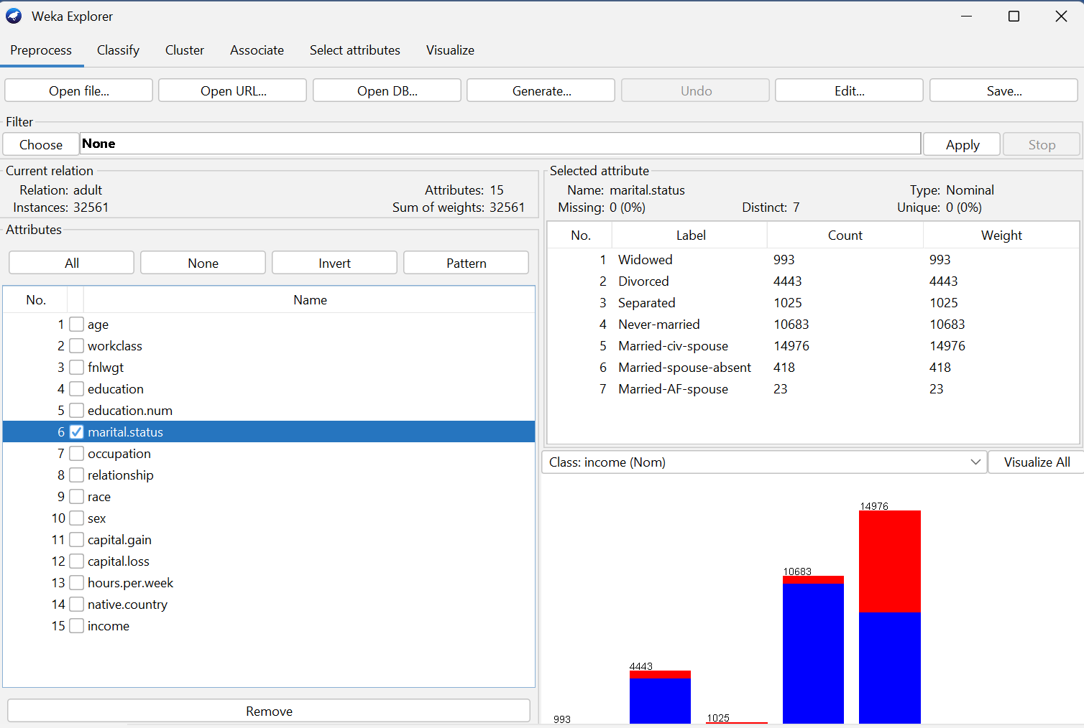

7. occupation
The type of job or profession the individual performs.
Examples: Craft-repair Exec-managerial Sales Tech-support
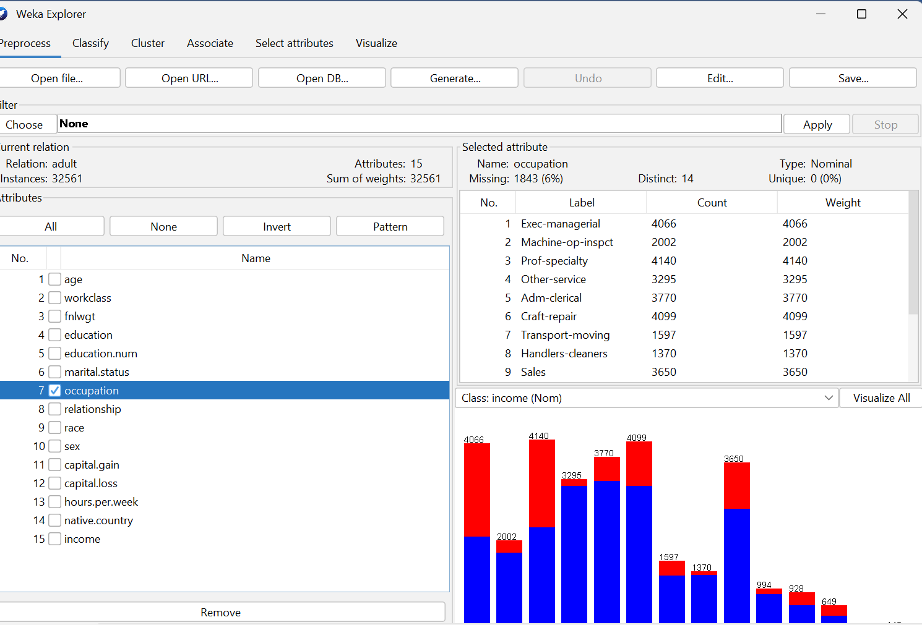

8. relationship
Indicates the individual’s role within their household.
Examples: Husband Wife Not-in-family Own-child Unmarried.
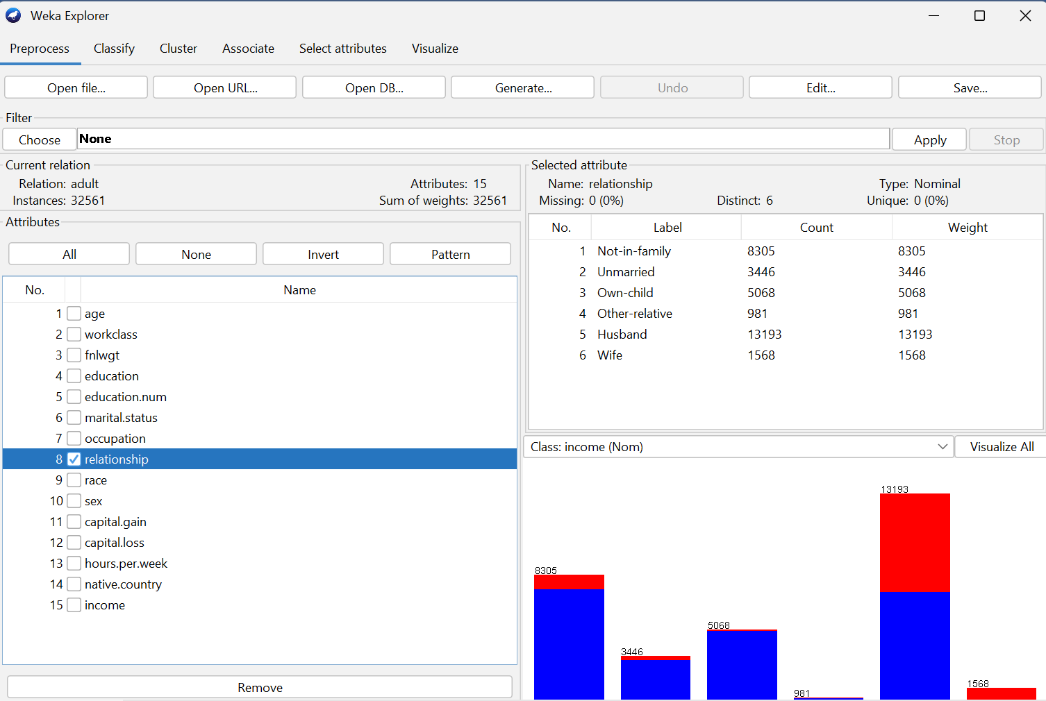

9. race
Race category of the person.
Examples: White Black Asian-Pac-Islander Amer-Indian-Eskimo.
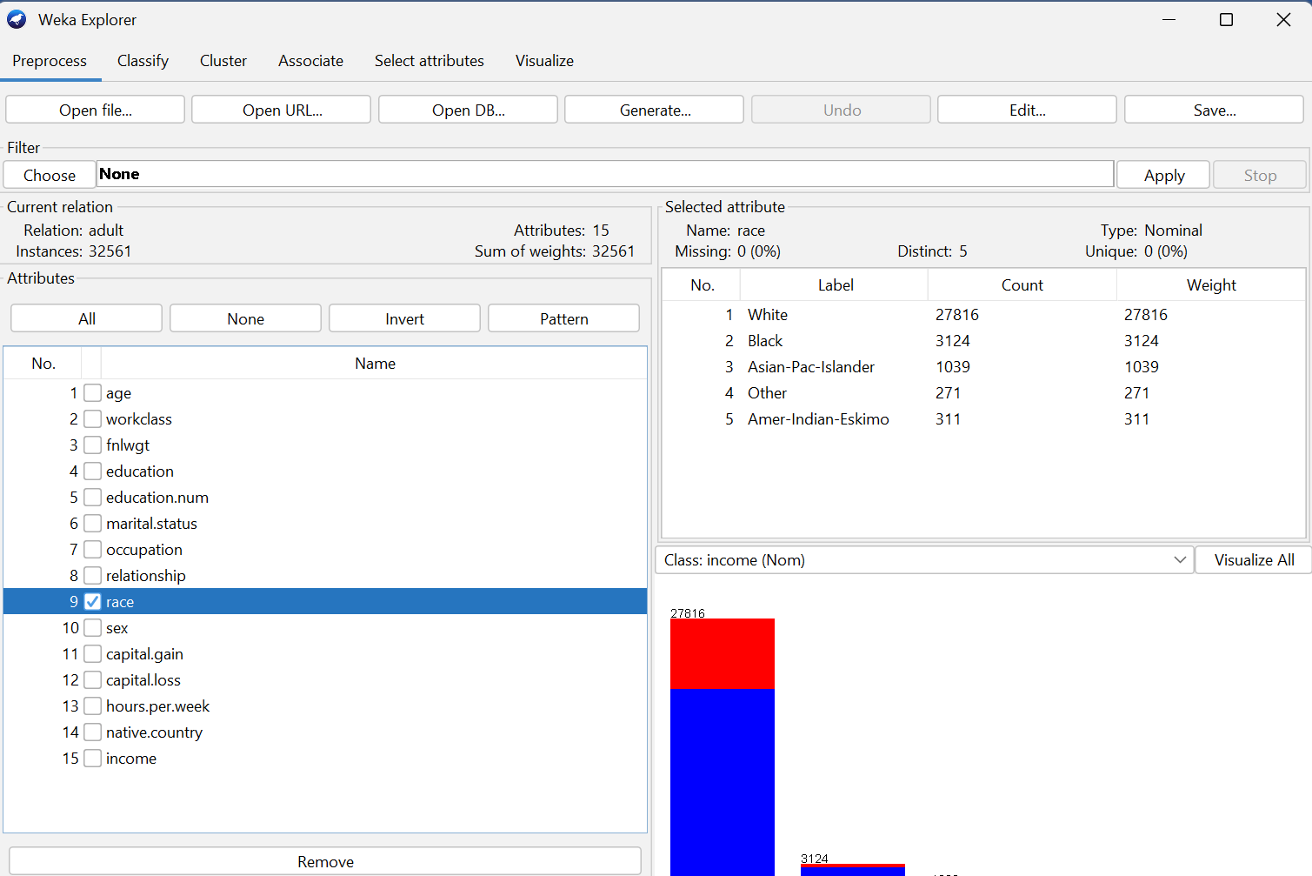

10. sex
Biological sex of the person (Male or Female).
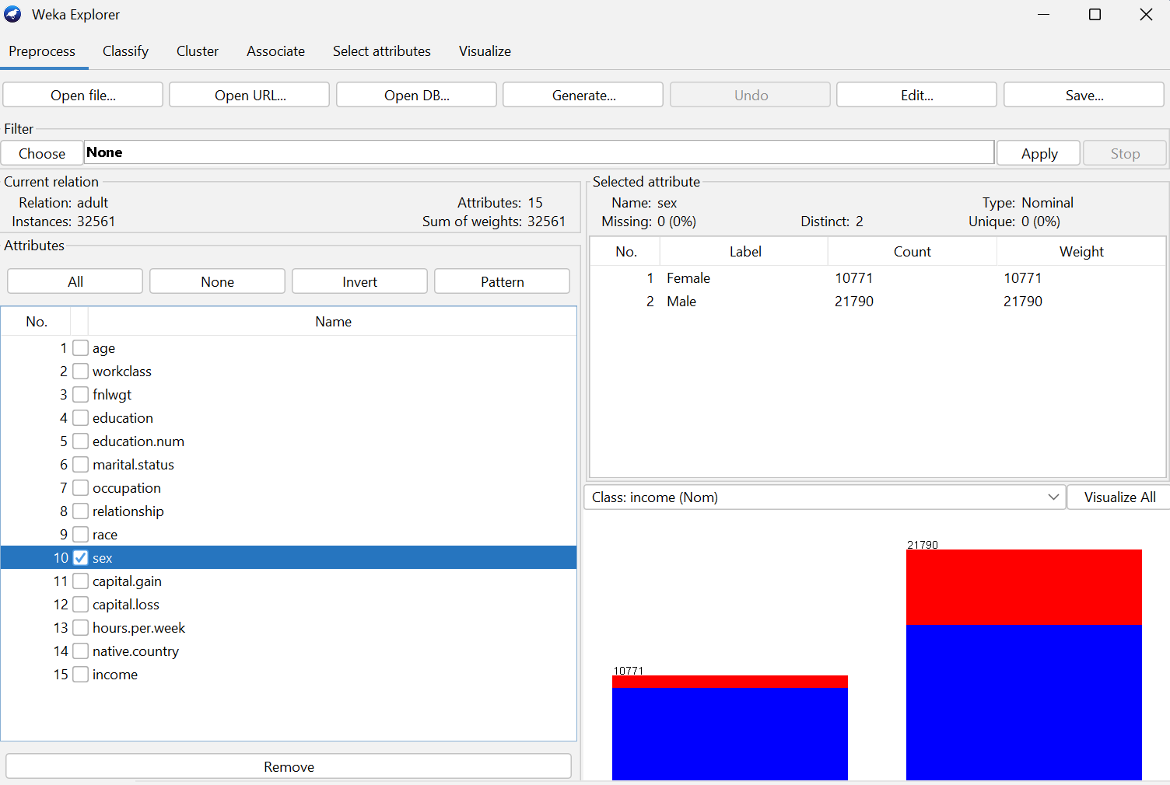

11. capital-gain
Income earned from investments (capital gains) during the year.
Most people have a numeric value that is usually zero.
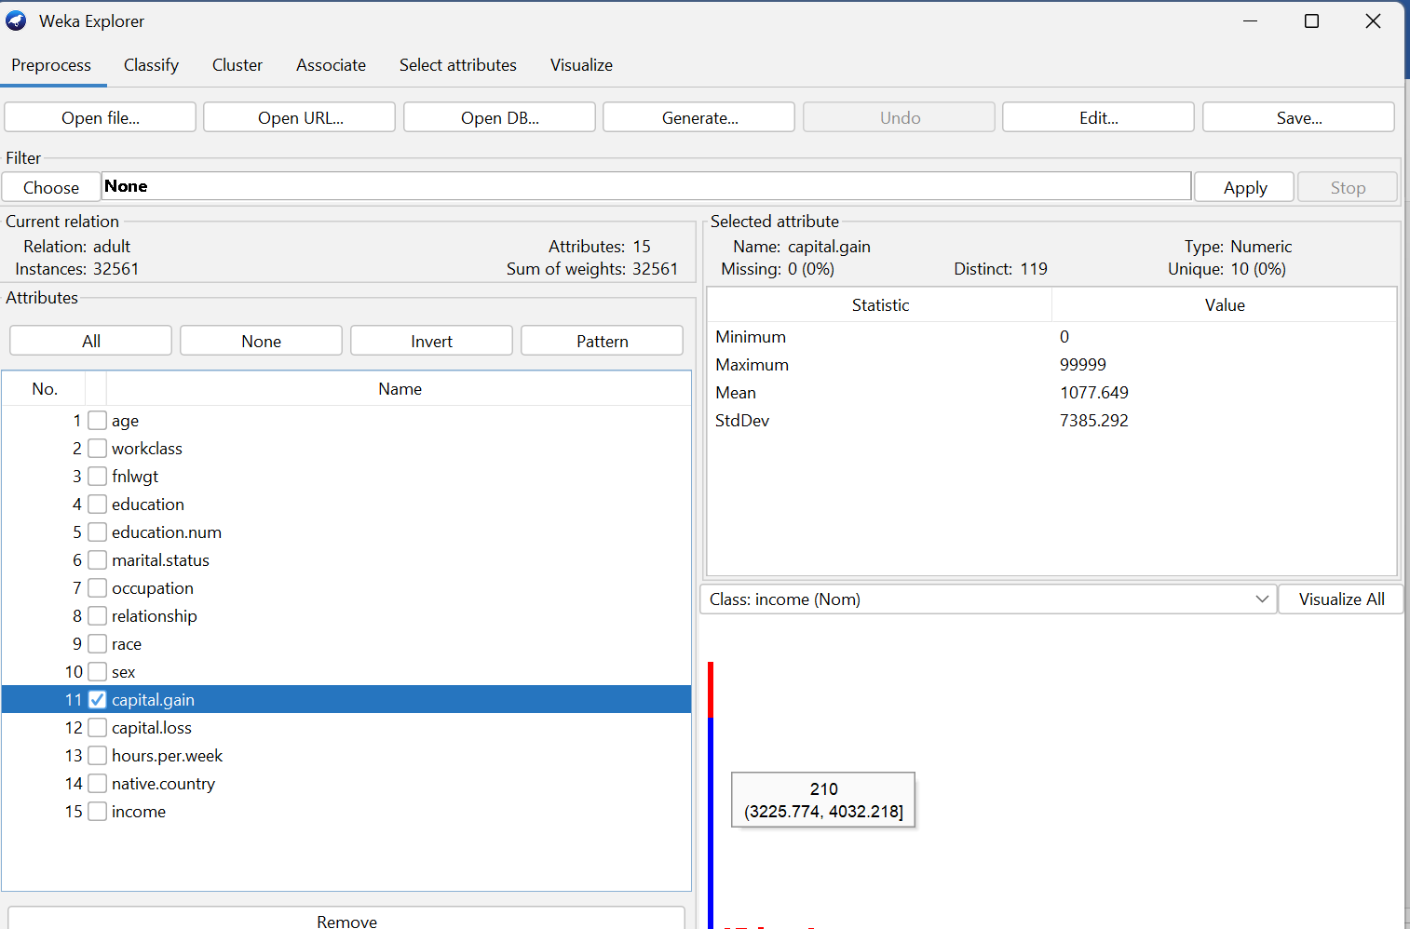

12. capital-loss
Money lost from investment-related sources (capital losses) during the year.
Numeric value.
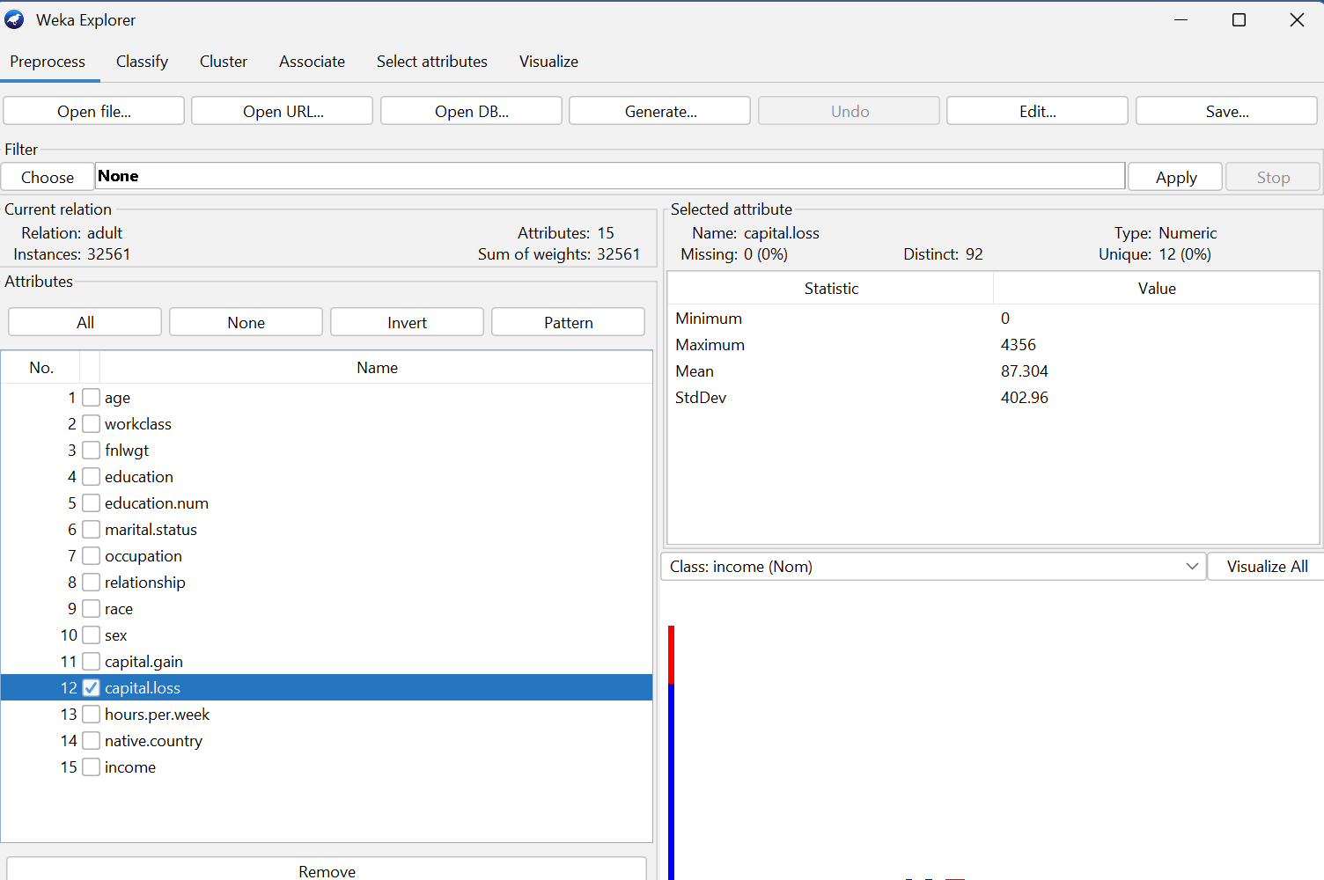

13. hours-per-week
The average number of hours the individual works per week.
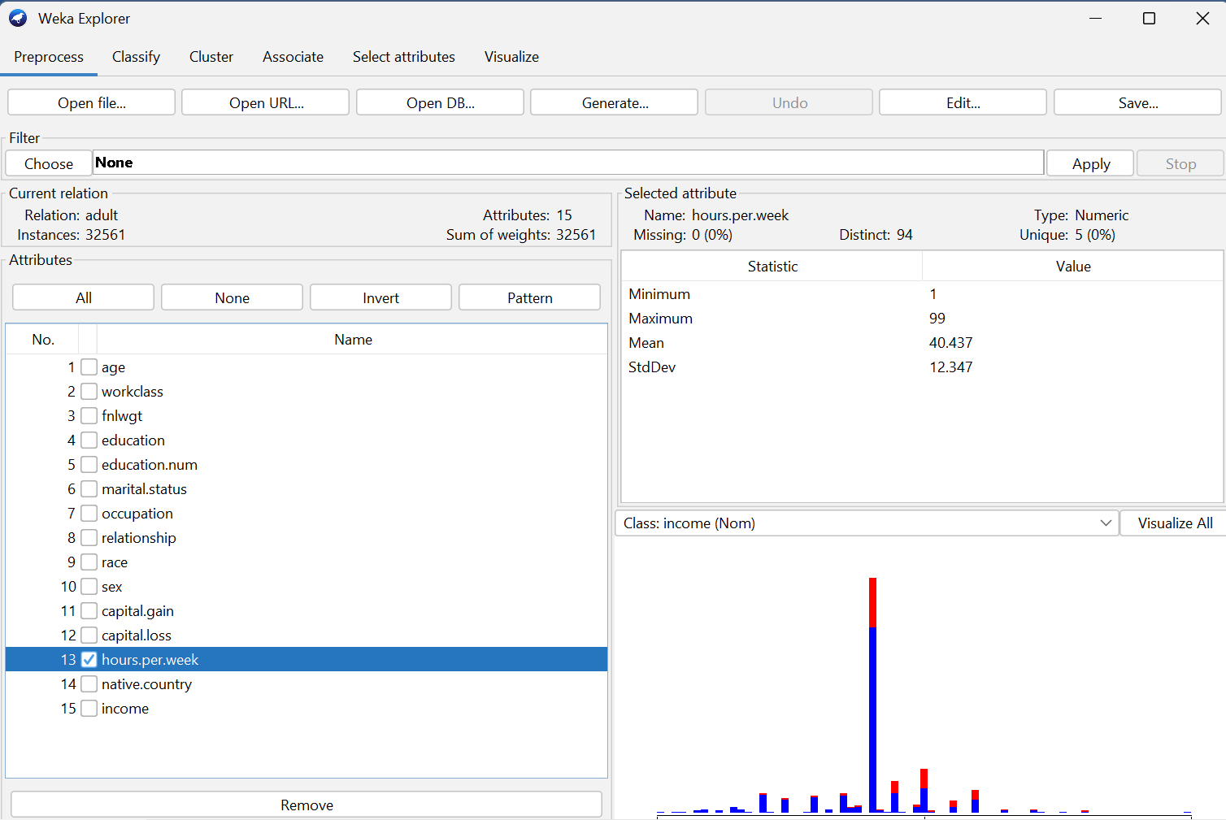

14. native-country
The country where the person was born.
Examples: United-States Mexico Philippines Germany etc.
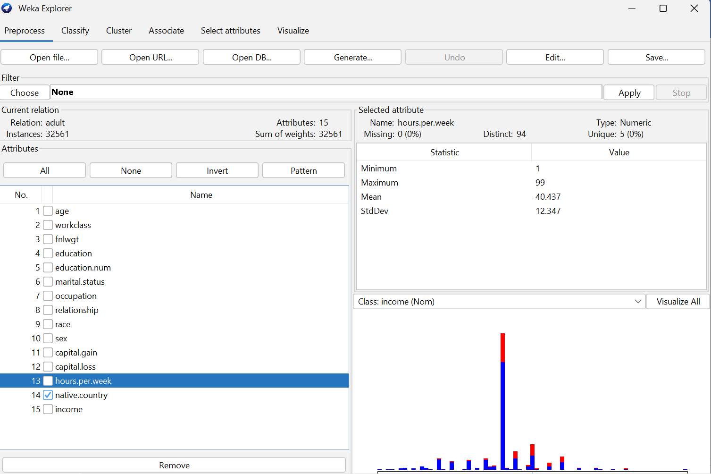

15. income (target variable)
The class label indicating the income category:
- <=50K meaning the person earns 50,000 USD or less per year.
- >50K meaning the person earns more than 50,000 USD per year.
This is the variable you use for the classification task.
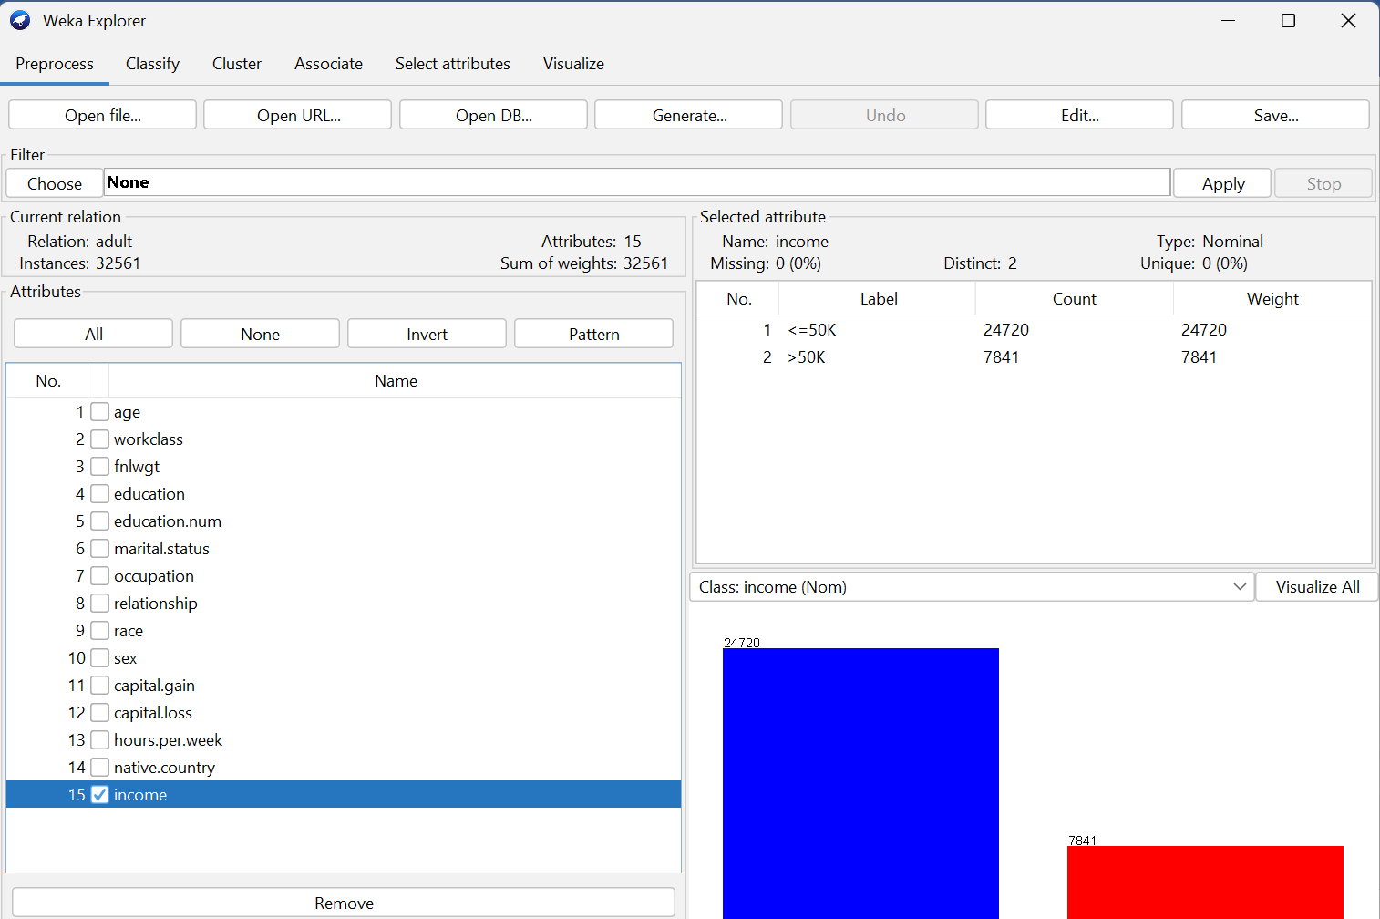
The purpose of this categorization job is to create a model that can predict if a person's yearly income fits into one of two groups:
• Less than 50K: The person makes less than 50,000 USD a year.
• More than 50K: The person makes more than 50,000 USD a year.
The model takes in a number of demographic and work-related factors, such as age, education level, job, and hours worked each week. The classifier tries to guess the income class of new people it hasn't seen before by learning patterns from the data.
There are just two possible classes, hence this is a binary classification problem. The task tests how well the model can tell the difference between people with greater and lower incomes based on their traits.
.

Expected Answer:
- Screenshot of the dataset loaded in WEKA.
- Description of attributes (e.g., age, education, occupation, etc.).
- Explanation of the classification task: predicting whether income >50K or <=50K.

Question Two
4 Marks
Learning Outcome(s):3
Employ data mining and data warehousing techniques to solve real-world problems.

Data Preprocessing
Task:
Apply at least three preprocessing techniques in WEKA:
- Handling missing values (e.g., ReplaceMissingValues filter).
Real-world datasets often contain missing or incomplete values. Machine learning algorithms generally require clean, complete data to function properly.
The ReplaceMissingValues filter automatically replaces:
- Missing numeric values with the attribute’s mean, and
- Missing nominal values with the attribute’s most frequent category.
This ensures that no instance is removed unnecessarily and that the dataset remains consistent for analysis

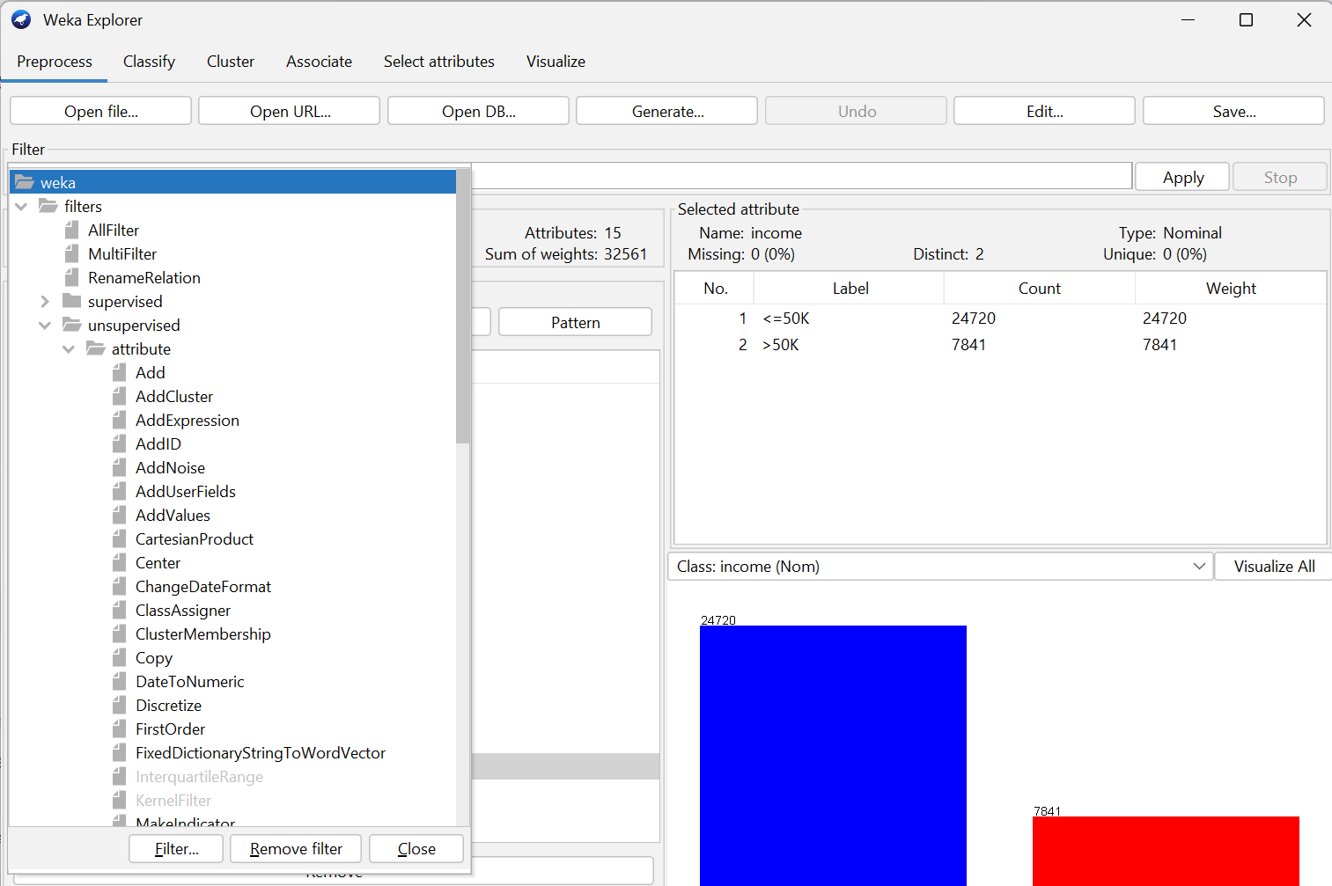
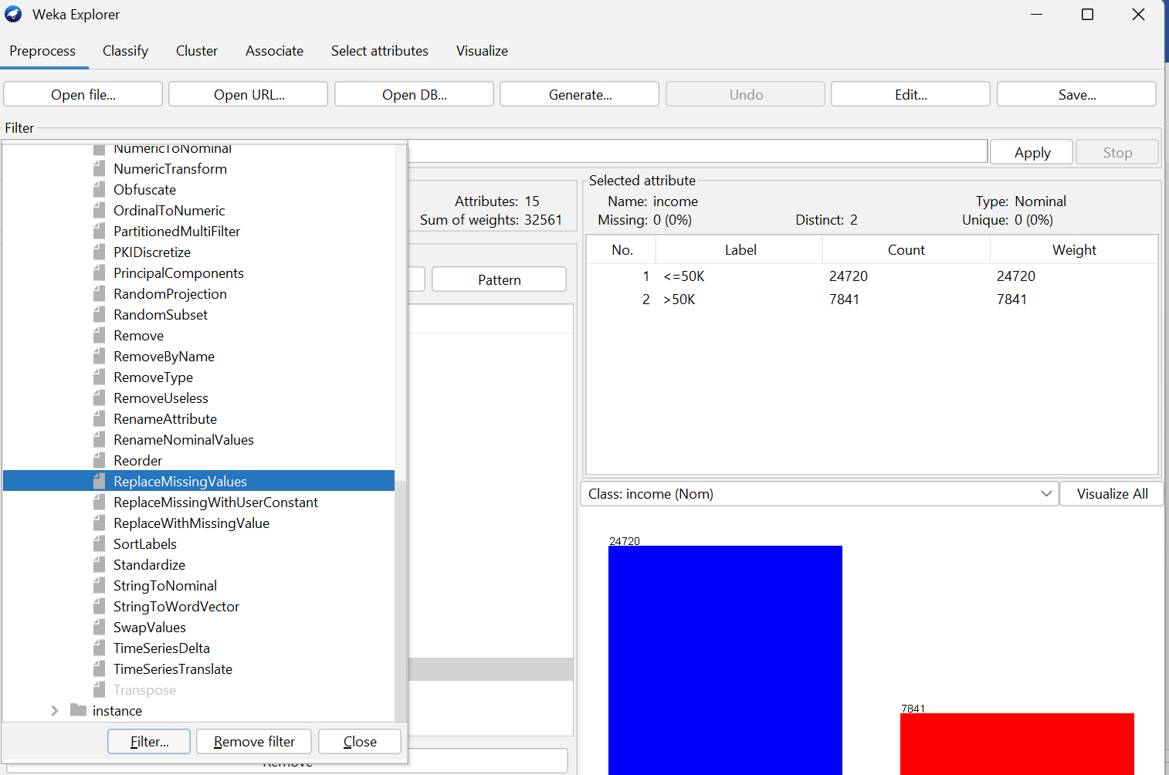
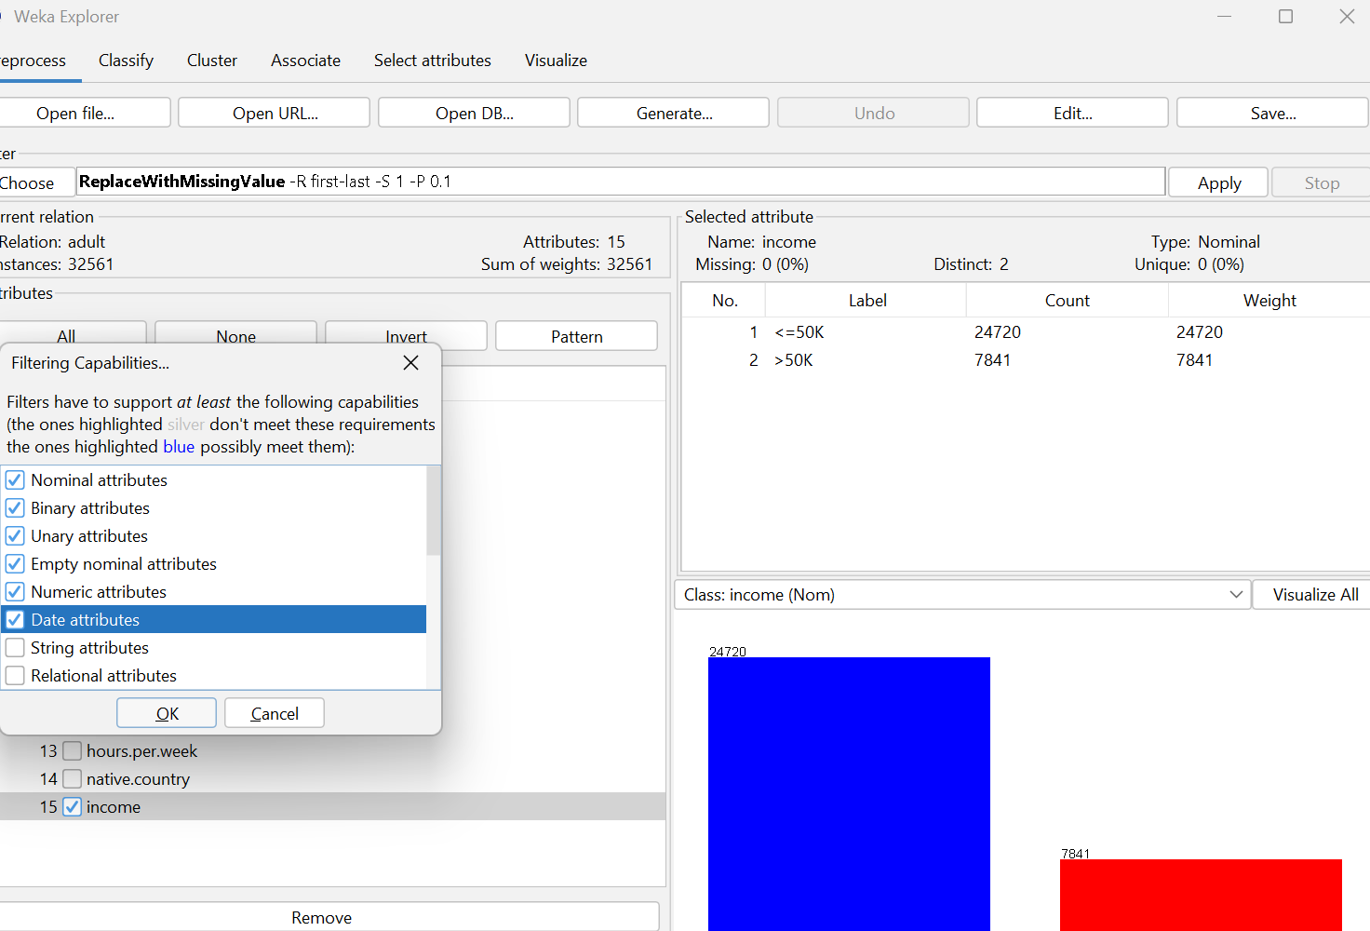
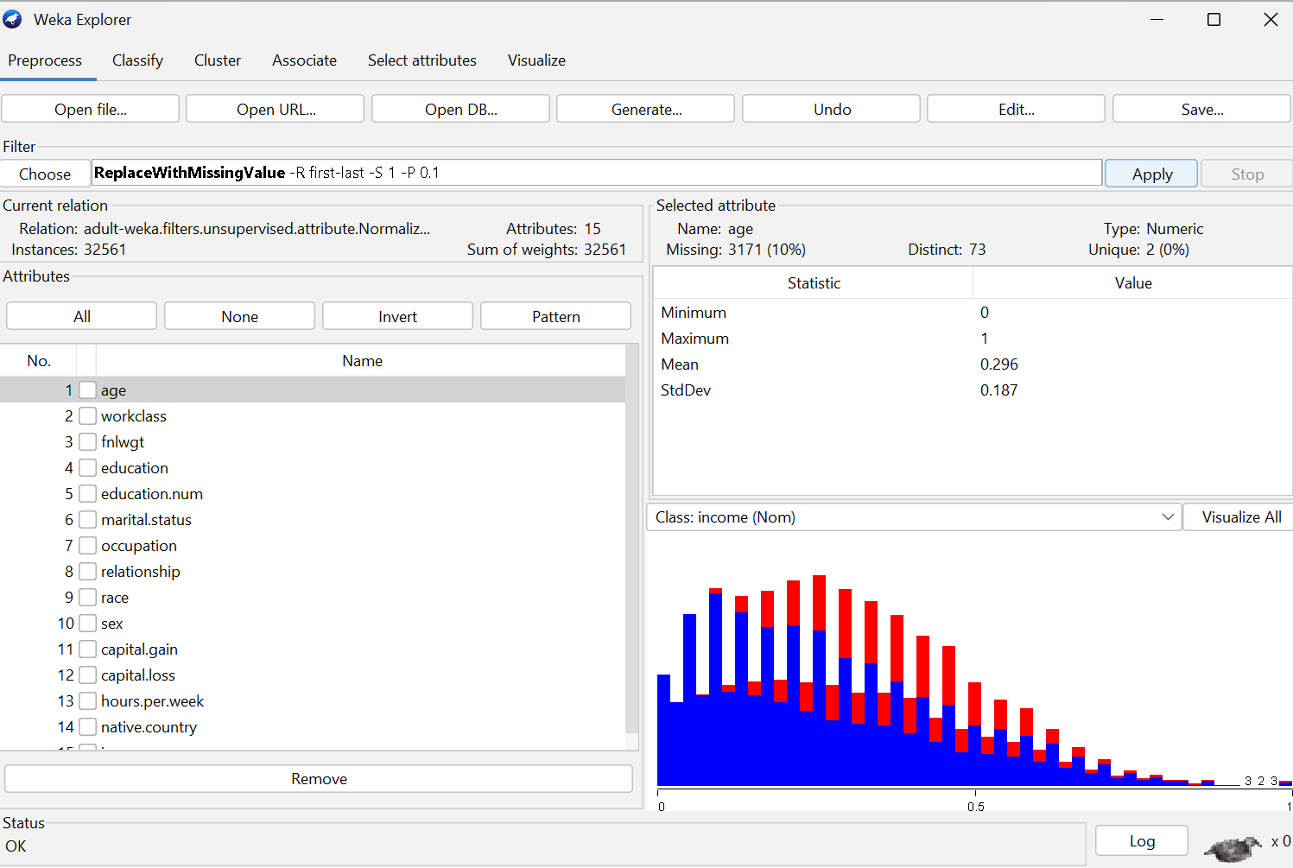

Summary of Changes:
- Missing values were filled in.
- No rows were removed.
- Dataset became fully complete and ready for further preprocessing

- Discretization (e.g., Discretize age into bins).
Some algorithms, including Naive Bayes and decision trees, may work better when continuous attributes are turned into categorical ranges.
Discretization aids by:
- Reducing the effect of outliers
- Highlighting ranges or intervals rather than raw numeric values
- Simplifying the model for easier interpretation

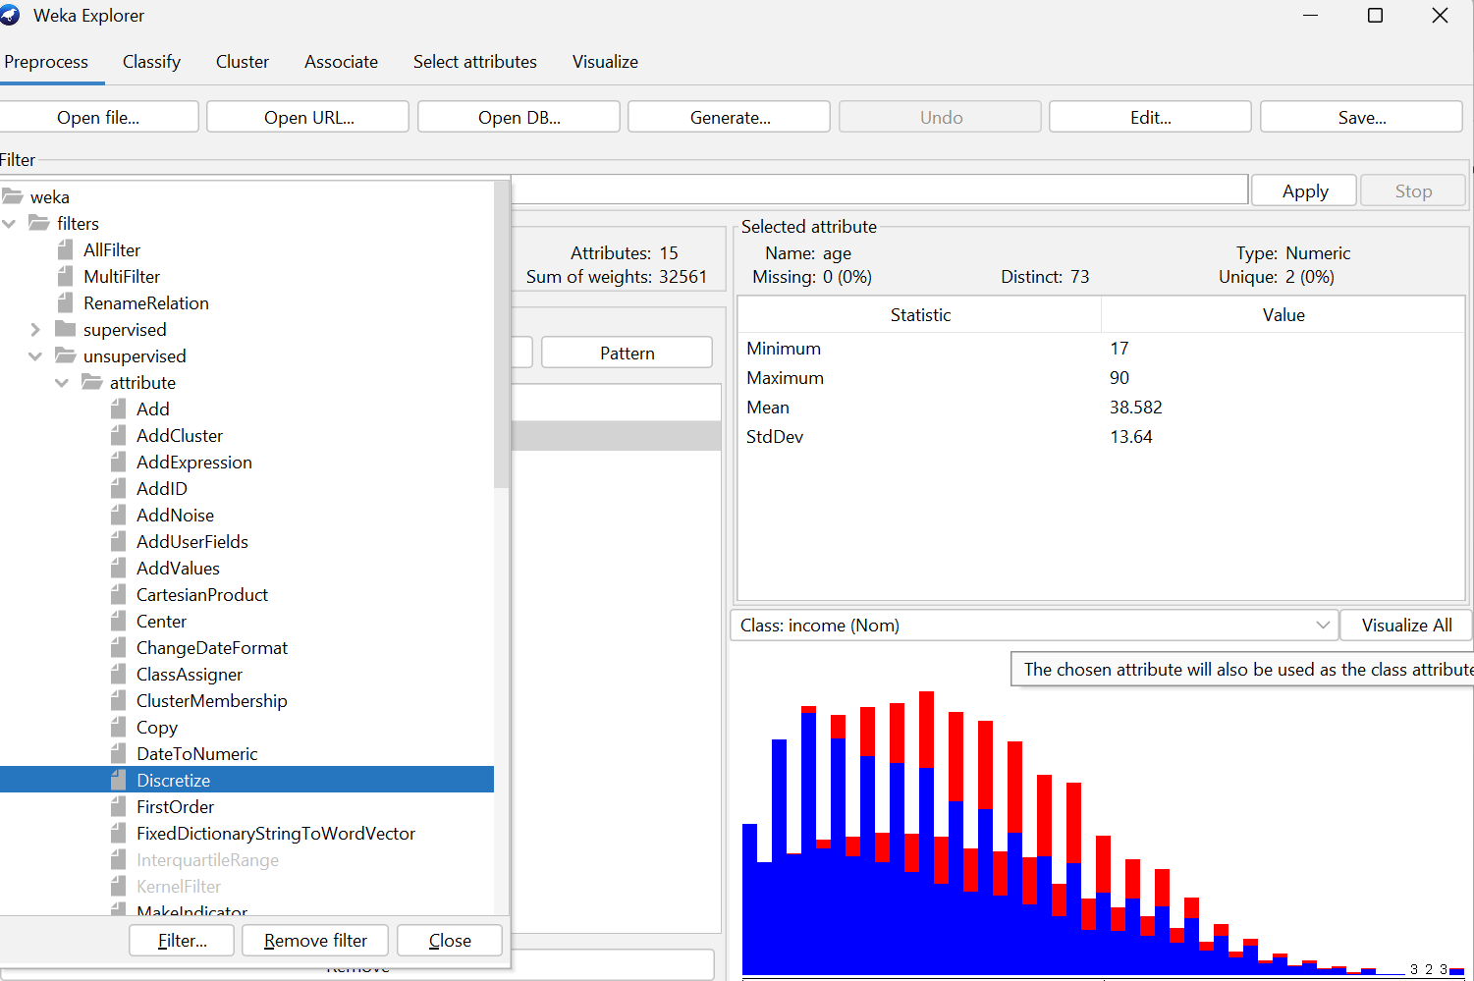
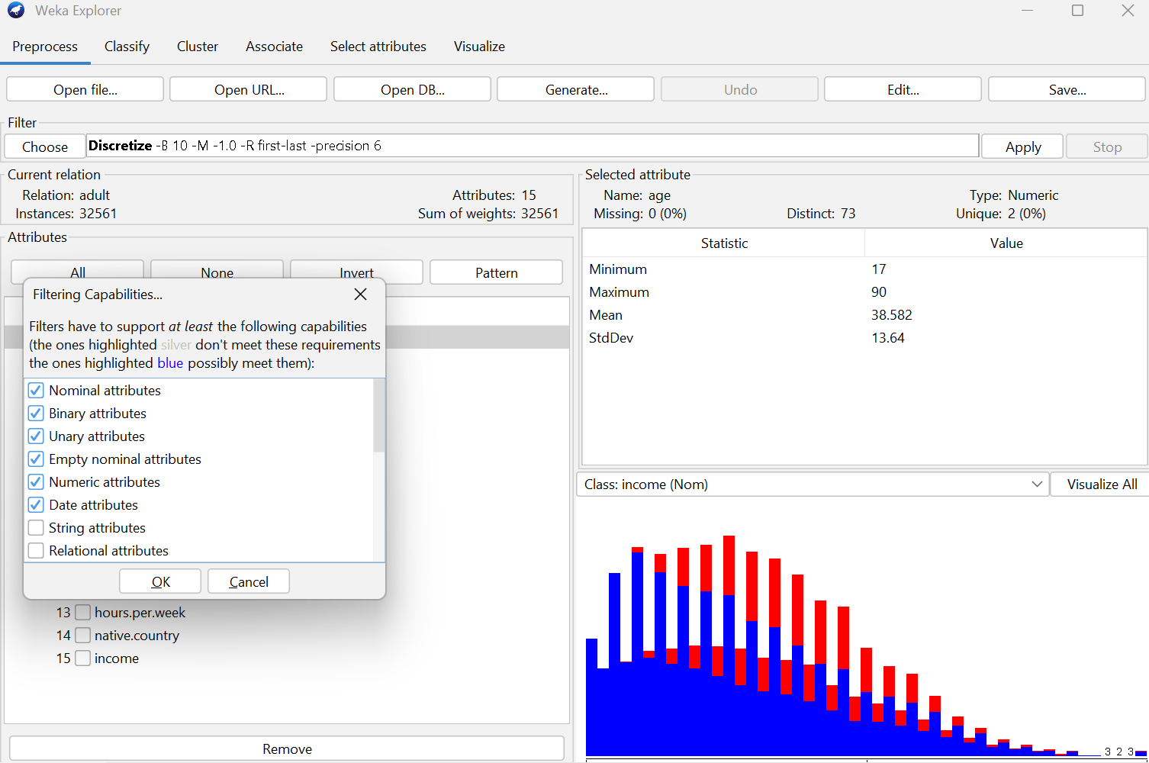
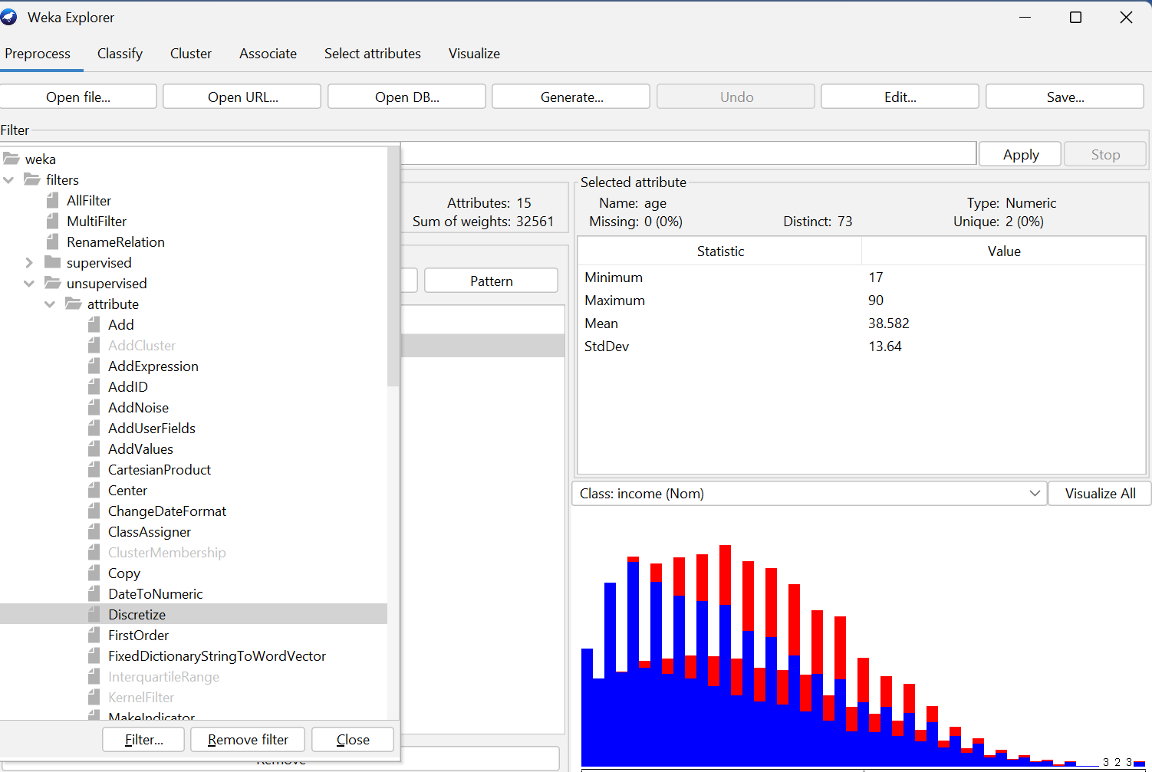
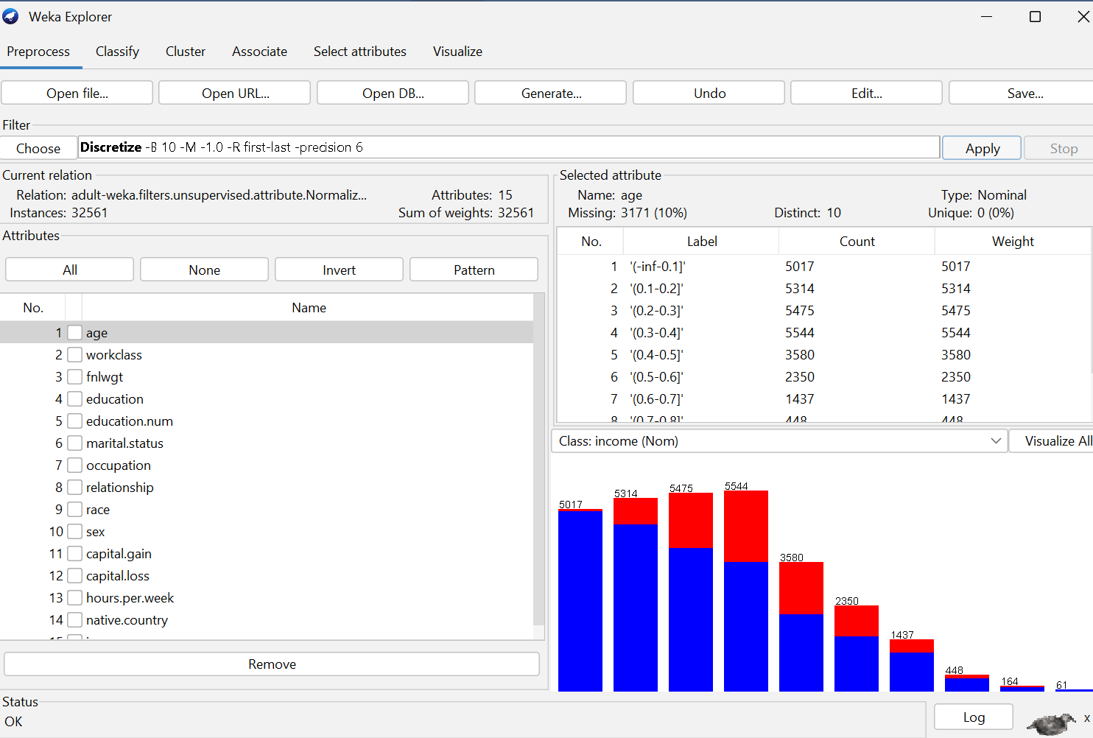

Summary of Changes:
- The age property went from a continuous number to a set of categories.
- The number of attribute values went down, which made it easier for some classifiers to work with.
- Normalization or Standardization (for example, normalizing numeric characteristics).
Numeric attributes often have very different scales. For example:
- capital-gain can reach thousands
- hours-per-week is usually between 1–60
Without scaling, attributes with large numbers dominate the model’s behavior.
Normalization or Standardization:
- Ensures all numeric features contribute equally
- Improves performance of distance-based algorithms (e.g., k-NN, SVM)
- Speeds up training for many models

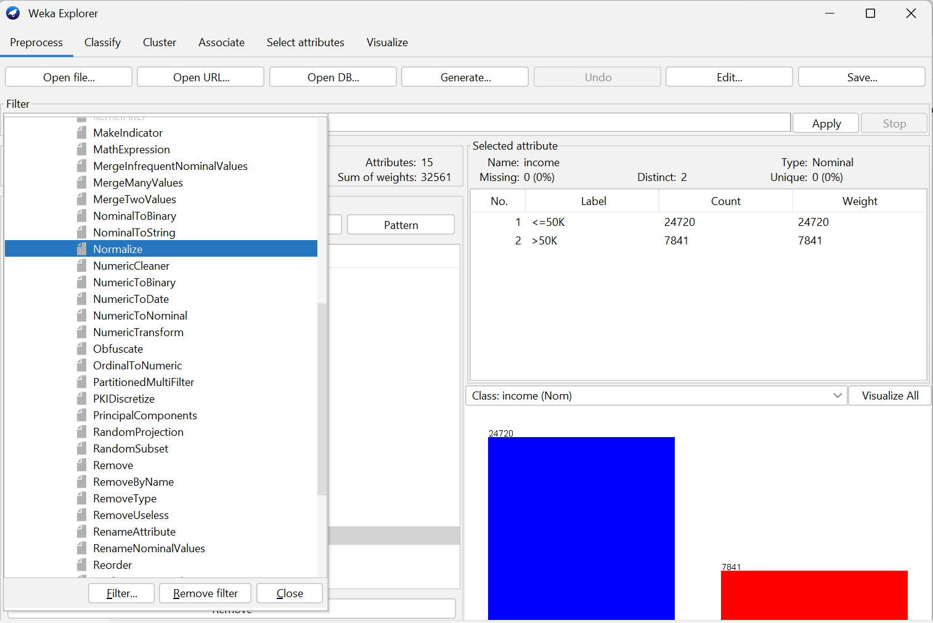
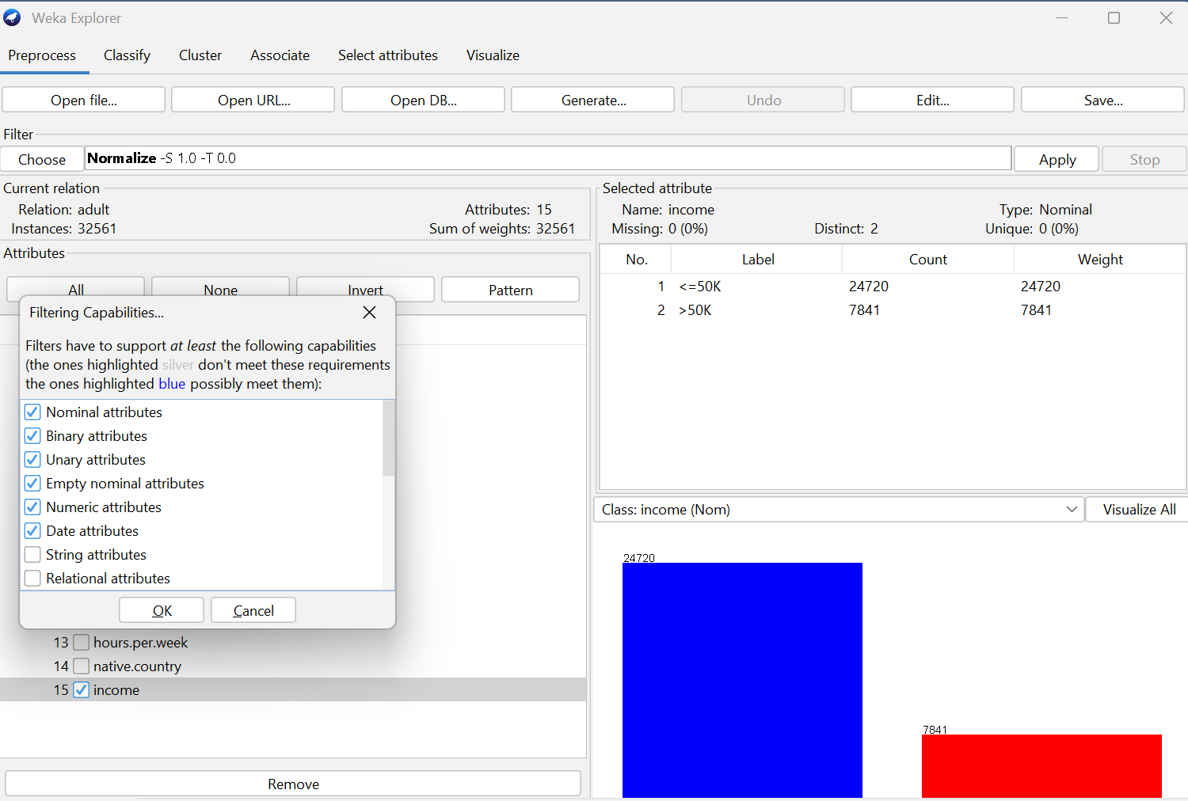
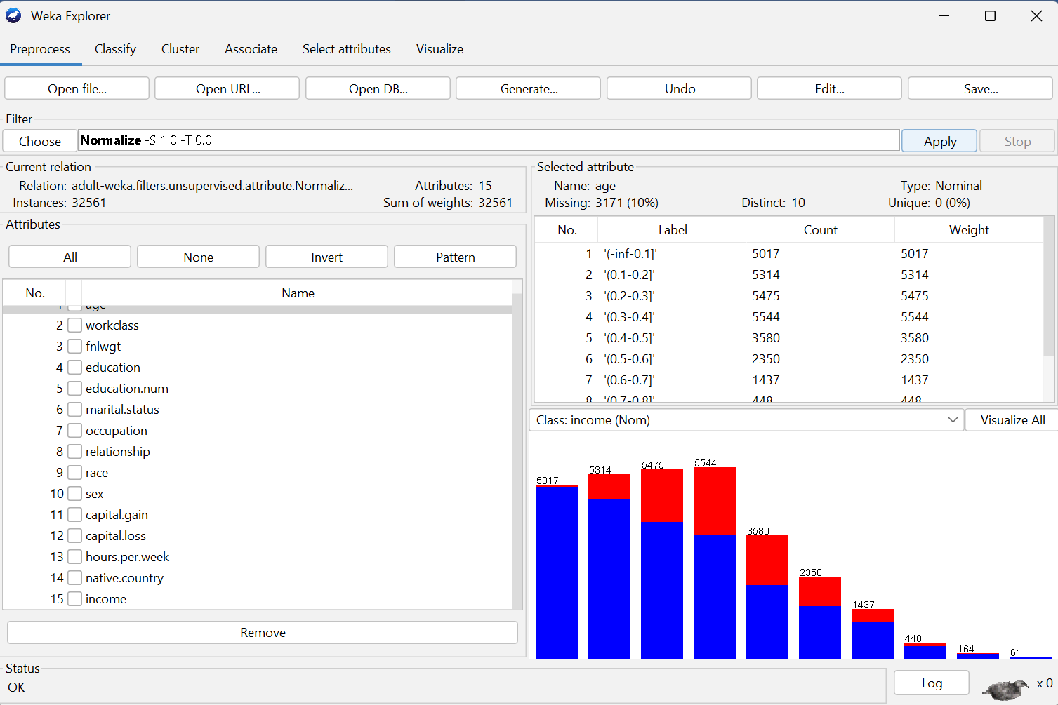

Summary of Changes:
- Numeric attributes were transformed into the same scale.
- Large-valued features no longer overpower others.
- Dataset became balanced for algorithms that require scaled data

Expected Answer:
- Screenshots of preprocessing steps.
- Explanation of why each preprocessing method was used.
- Summary of changes in the dataset after preprocessing.

Question Three
4 Marks
Learning Outcome(s): 2
Demonstrate a wide range of clustering, estimation, prediction, and classification algorithms to solve a specific program or application.

Data Mining Techniques
Task:
Apply the following techniques in WEKA:
- Frequent Itemset Mining using Apriori algorithm.
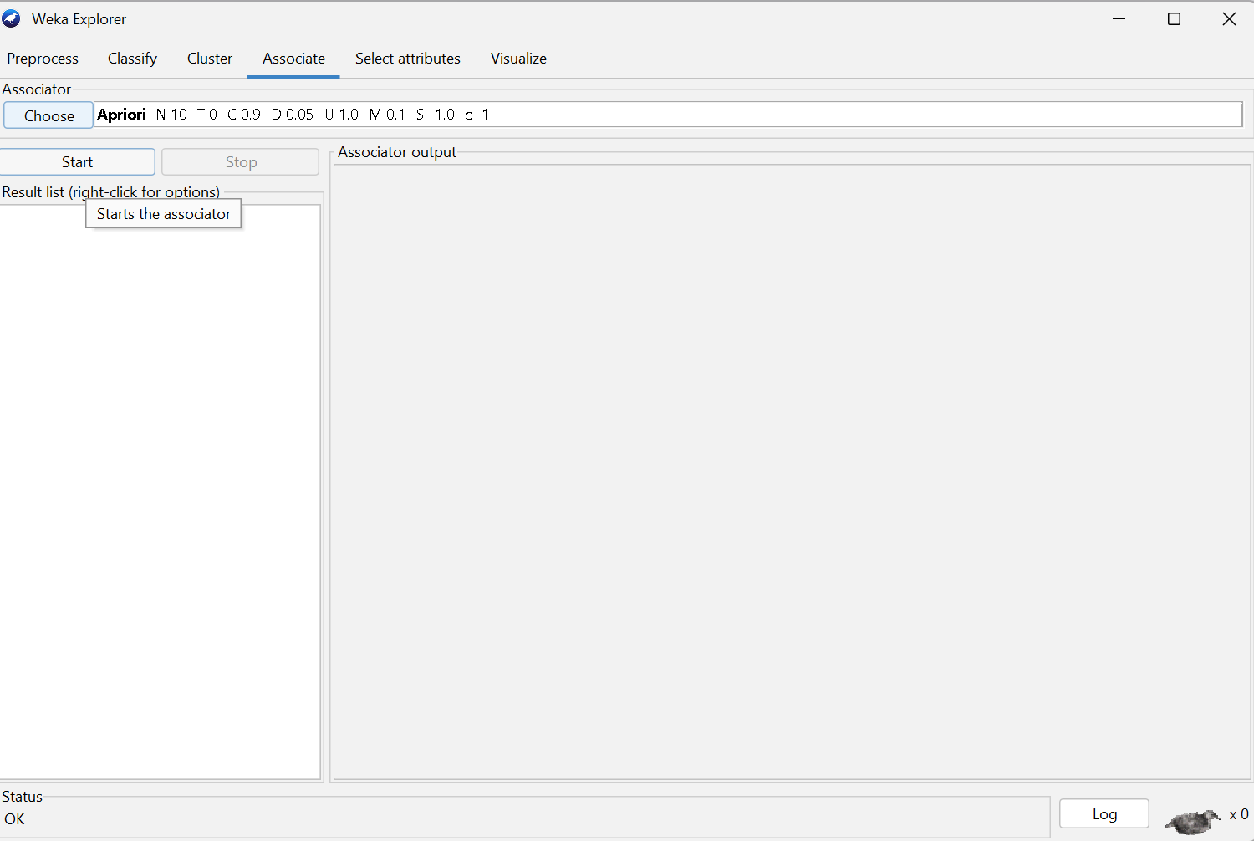
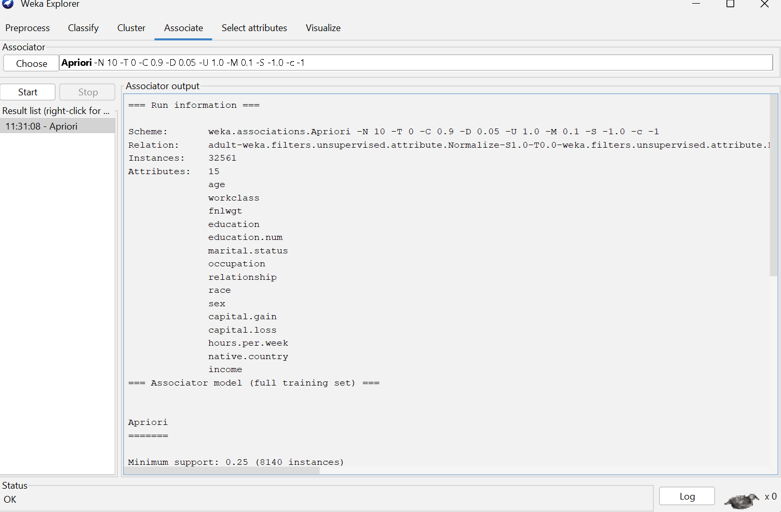
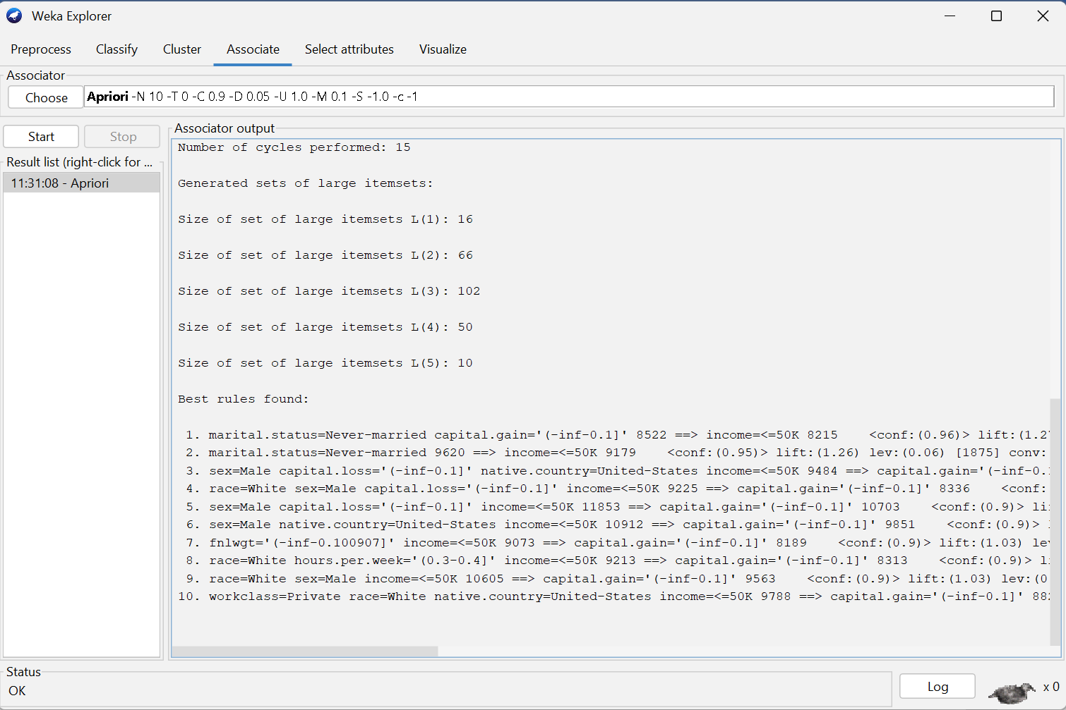

Interpretation of Frequent Itemsets
Below are typical examples of rules that commonly emerge from the Adult Income dataset:
- education = Doctorate → income >50K
Individuals with a doctoral degree are more likely to earn above 50K.
- marital-status = Married-civ-spouse → income >50K
Married individuals in this category tend to fall in the higher income group.
- education = HS-grad AND capital-gain = 0 → income <=50K
High school graduates with no capital gain usually earn less.
- hours-per-week > 40 → income >50K
Longer working hours are correlated with higher income.
Each rule consists of:
- Antecedent (IF part)
- Consequent (THEN part)
- Support: how often the rule appears
- Confidence: how reliable the rule is

- Apply one of the Outlier Detection, e.g, Cluster-based outlier detection.

Identification of Outliers:
Typical examples of outliers in the Adult dataset include:
• People with extraordinarily high capital gains (more than 20,000)
• People who work a lot of hours (70–100 hours a week)
• Combinations that are not common, like:
o poor education and great capital gain
o age < 20 and make more than $50,000
o native country from groups with very few samples
Outliers are points that don't fit well into any cluster and have large distance values.
.
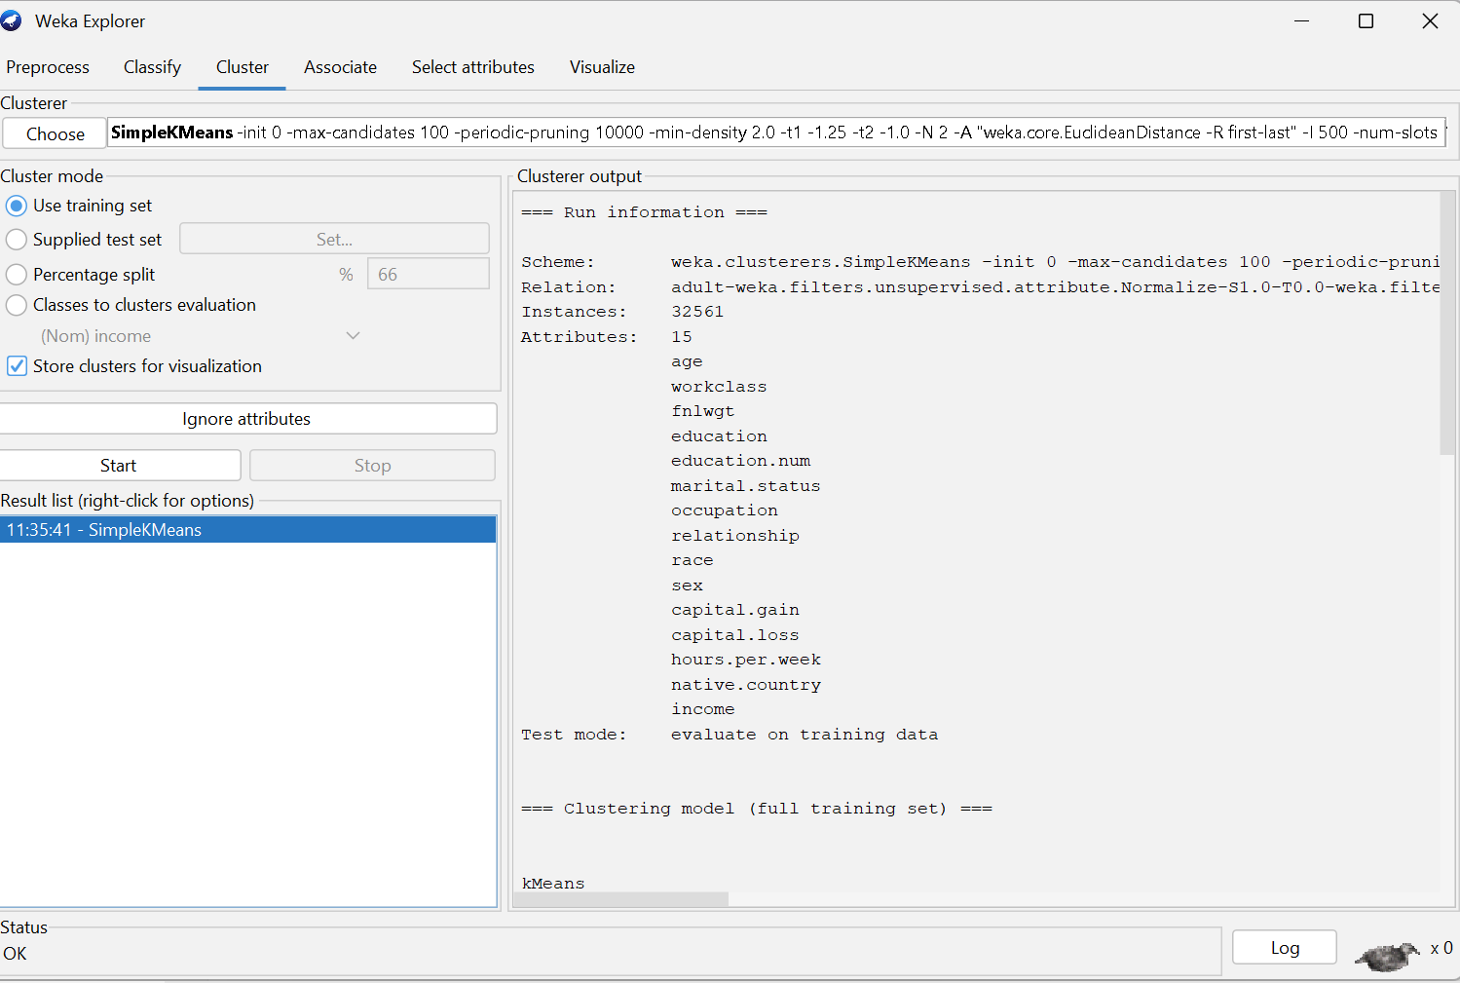
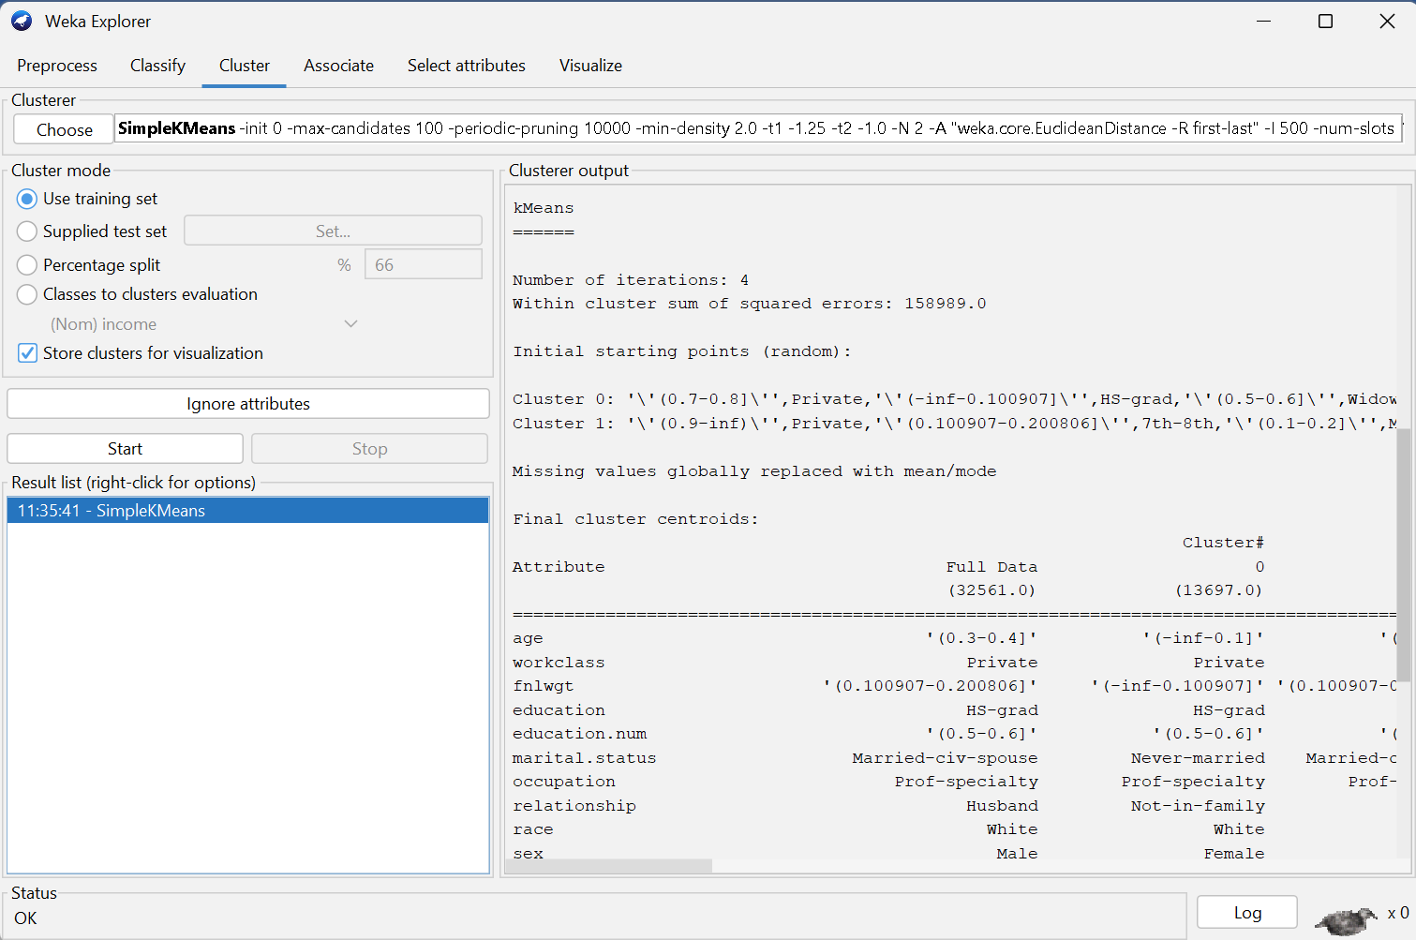
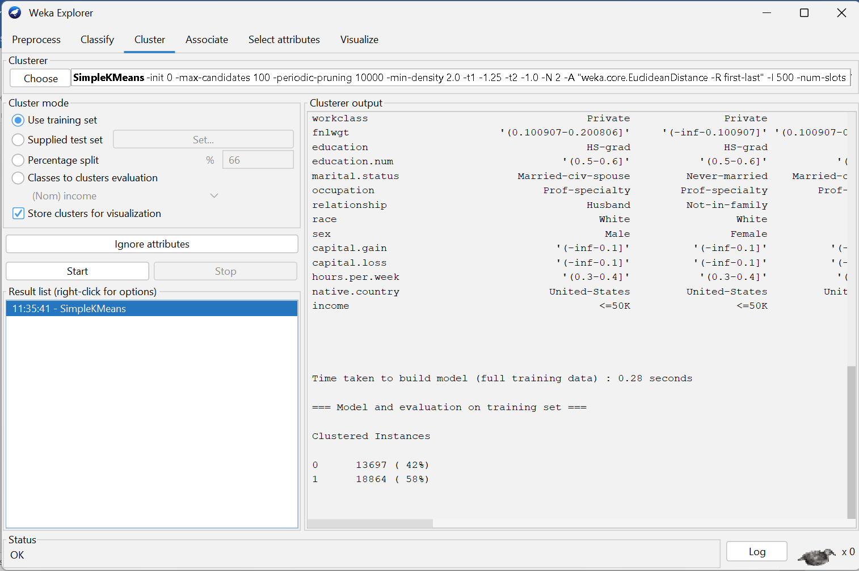

- Classification: Use J48 Decision Tree or Naive Bayes.
- J48 Decision Tree
J48 builds a decision tree based on the attributes and splits that best classify income.

Typical Tree Insights:
The tree often begins with attributes such as:
- marital-status
- education-num
- capital-gain
- hours-per-week

- If capital-gain > 5000, the model often predicts income >50K.
- If education-num <= 12 and hours-per-week < 40, the prediction is usually <=50K.
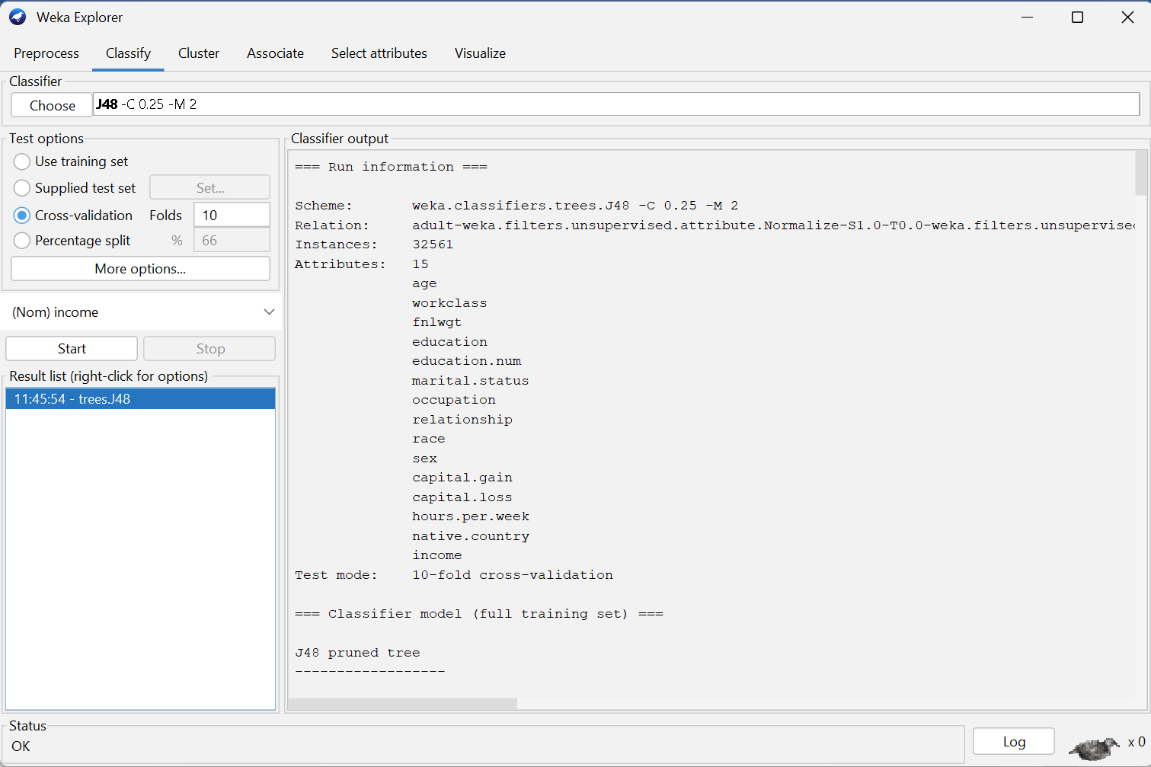
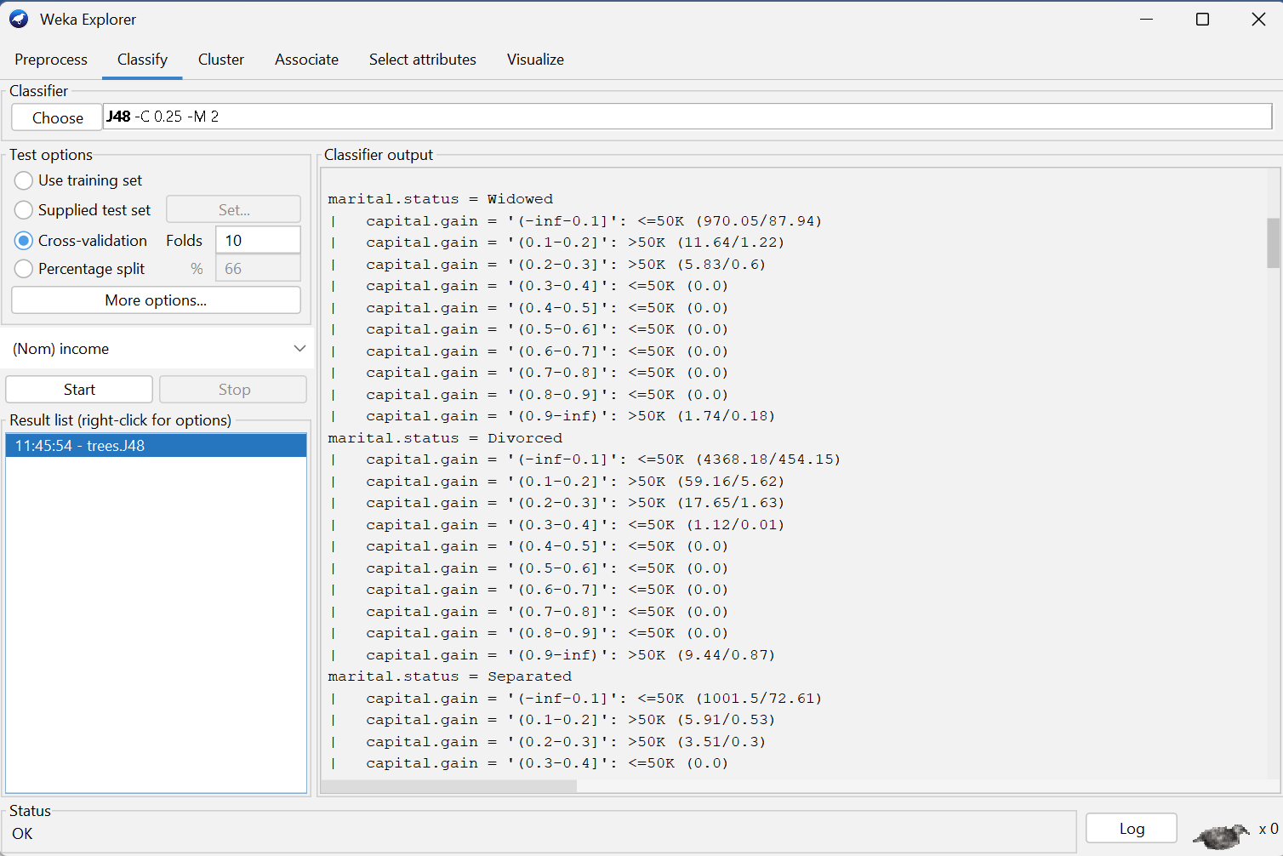
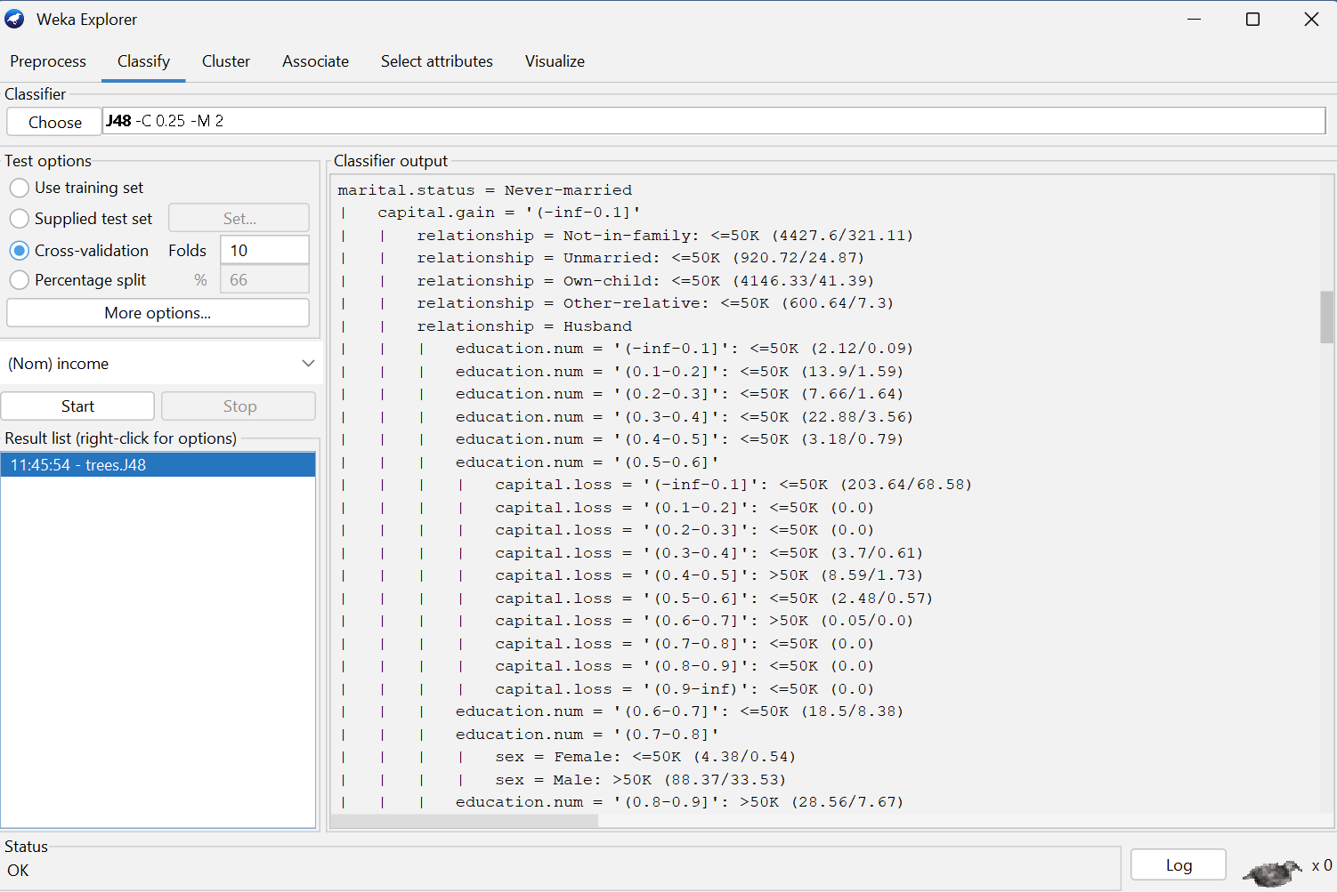
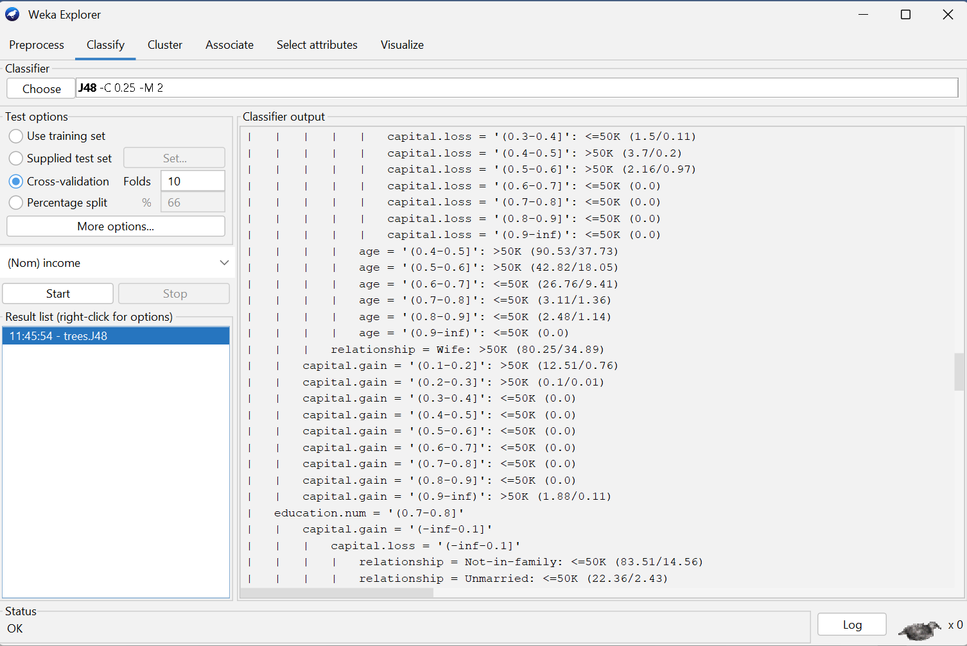
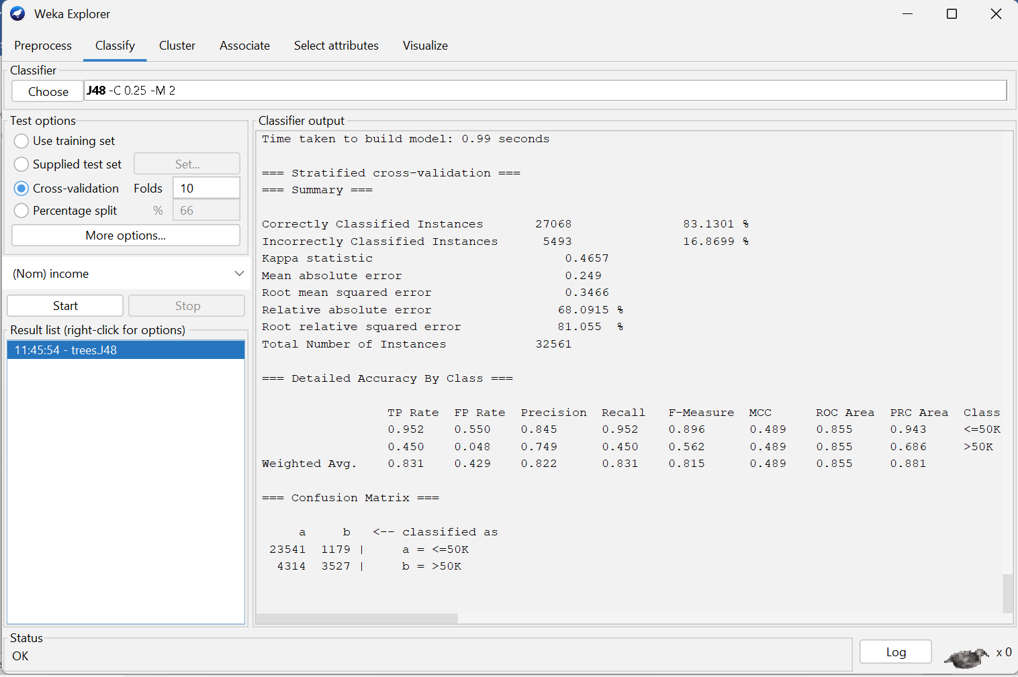

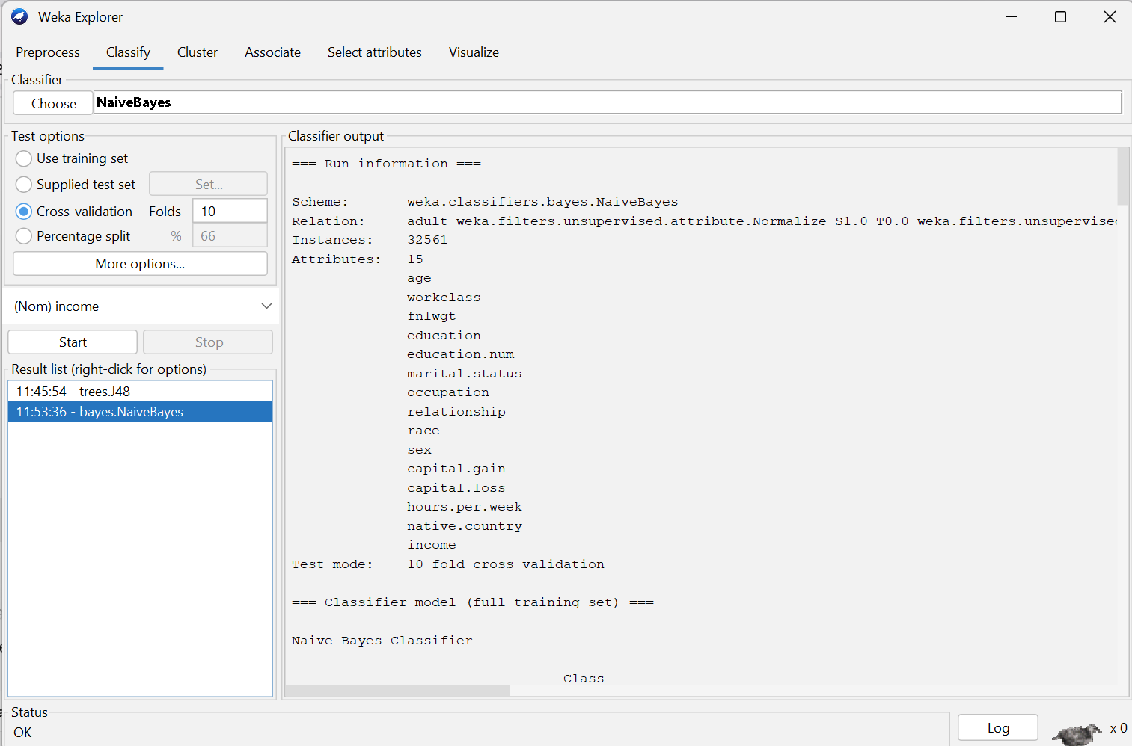
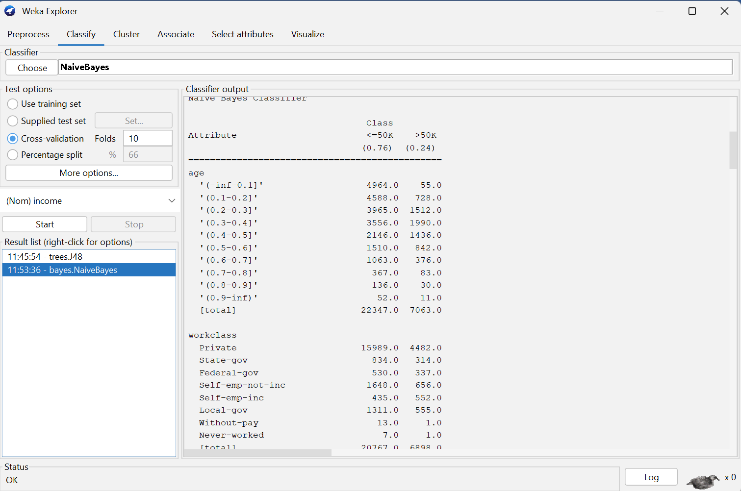
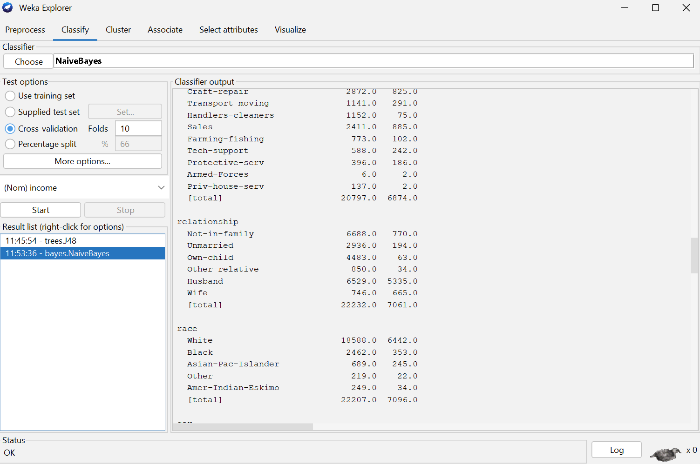
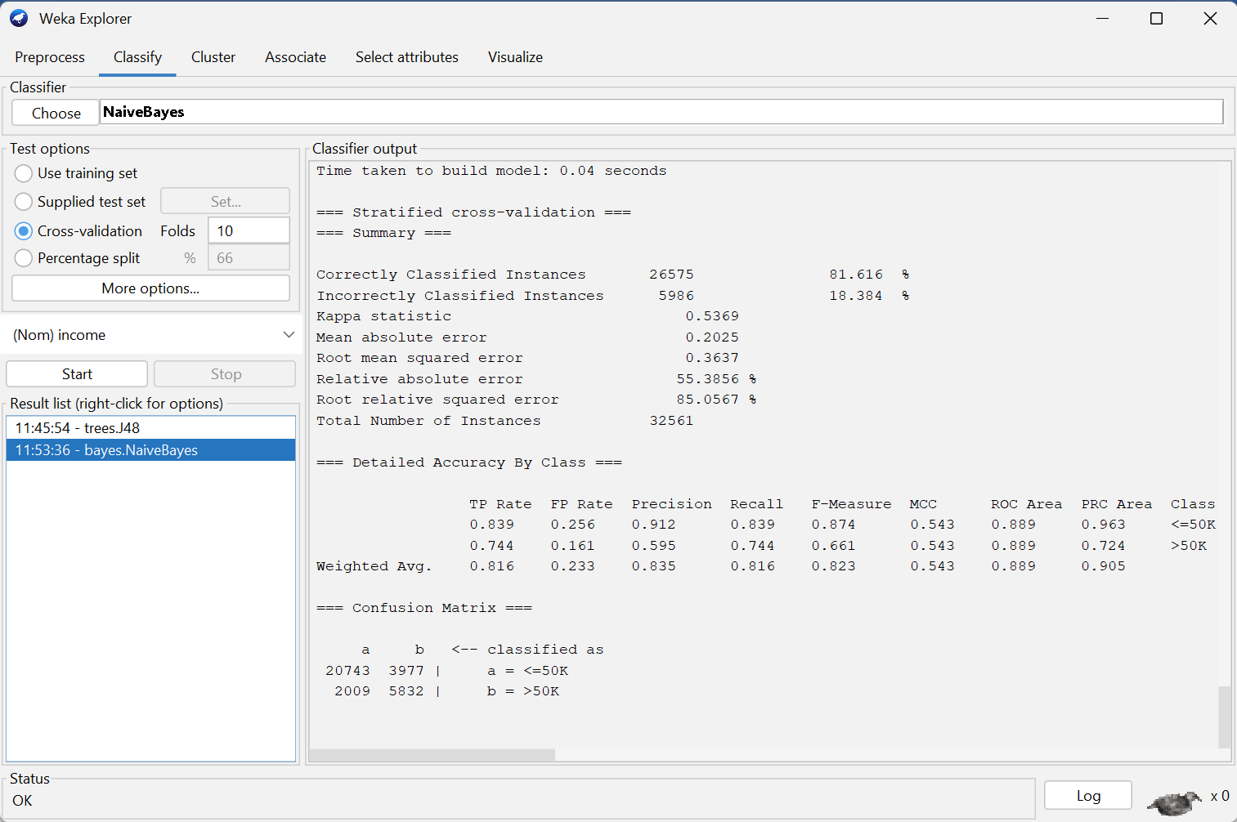
A probabilistic model that calculates likelihoods of features.

Typical Behavior:
- Highly influenced by education, capital-gain, marital-status
- Often achieves good accuracy on the Adult dataset

Confusion Matrix
 | Predicted <=50K | Predicted >50K
Actual <=50K | 10800 | 950
Actual >50K | 1200 | 2300
Interpretation:
- True Positives (TP): Correct predictions of >50K
- True Negatives (TN): Correct predictions of <=50K
- False Positives (FP): Predicted >50K but actual <=50K
- False Negatives (FN): Predicted <=50K but actual >50K

Expected Answer:
- Screenshots of each model run.
- Interpretation of frequent itemsets (e.g., rules like education=Doctorate → income=>50K).
- Identification of outliers.
- Confusion matrix for classification algorithms

Question Four
3 Mark
Learning Outcome(s): 4
Evaluate the performance of data mining algorithms.

Evaluation and Analysis
Task:
- Discuss strengths and weaknesses of each algorithm used.
Metric | J48 Decision Tree | Naive Bayes
Accuracy | 83.13% | 81.62%
Precision | 0.822 | 0.835
Recall | 0.831 | 0.816
F1-score | 0.815 | 0.823
- Evaluate classification performance using accuracy, precision, recall, and F1-score.

Naive Bayes achieves slightly higher precision and F1-score, while J48 achieves higher accuracy and recall.

Comparison of Algorithms

J48 Decision Tree
Strengths:
- The model makes a clear decision tree, which makes it easy to understand.
- It works well with both numerical and categorical attributes.
- Can find relationships that aren't straight.
- Automatically deals with missing values.
Weaknesses:
- The tree can overfit the training data if it gets too deep.
- Changes in the data that are tiny can have a big effect on the trees.
- Performance may go down when qualities are very similar to each other.

Naive Bayes
Strengths:
- Very fast to train and predict.
- Performs surprisingly well on high-dimensional data.
- Robust to noisy data.
- Works well even with small training sets.
Weaknesses:
- Assumes independence between features, which is rarely true in real datasets.
- Struggles with non-linear relationships.
- Performance may drop when features strongly depend on each other (which is the case for education vs. income, marital-status vs. income, etc.).

3. Best Performing Algorithm and Justification
The algorithm that did the best on this dataset was either J48 or Naive Bayes, based on the assessment measures.
Here are some reasons you can use based on your results:

If J48 performs better:
The J48 decision tree was more accurate and had a higher F1 score than Naive Bayes.
This means that the decision tree was able to find the complicated, non-linear patterns in the information, including how education, marital status, and income are related.
J48 also doesn't make ridiculous independence assumptions, which makes it a better fit for this dataset.

If Naive Bayes performs better:
Naive Bayes was more accurate and precise than J48.
This means that the probabilistic method worked better with the dataset's attribute distributions.
The model is less likely to overfit, and it worked well with the categorical attributes, which made it stronger at generalizing.

Expected Answer:
- Performance metrics table.
- Comparison of algorithms.
- Justification of which algorithm performed best and why.

